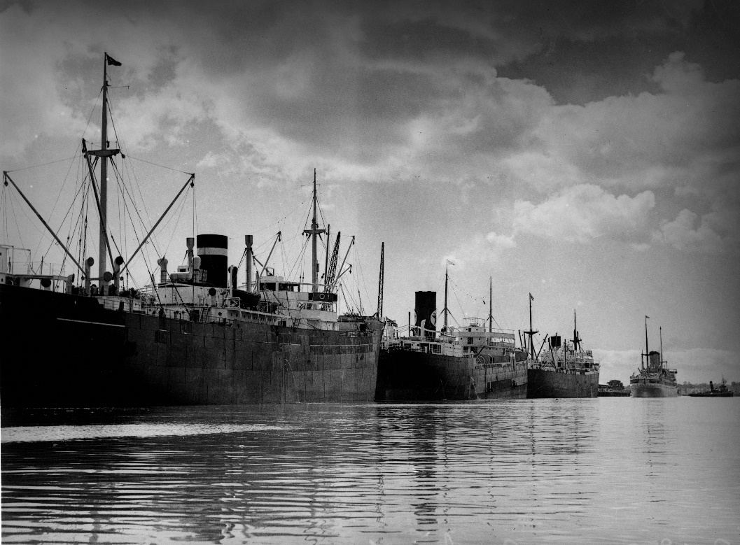

The transformation of Northshore
1820–2020

200 years of history

Introduction

The Northshore Hamilton Priority Development Area (PDA) (Northshore) covers 304 hectares only six kilometres from Brisbane central business district. Northshore is relatively flat and is bounded on its south by the Brisbane River, on the north by Kingsford Smith Drive, on the west by the Brett’s Wharf CityCat terminal and, on the east, by the Gateway Motorway. With over three kilometres of Brisbane River frontage and close to the river mouth, Northshore enjoys breezes from Moreton Bay and views of the river, central business district and the mountain ranges.

Before the area was reclaimed—much of Northshore was sandbank, river and swamp. Aboriginal people resided near the banks of the river opposite a large sandbank they called Mooroo-mooroolbin or ‘long nose’ or ‘Hamilton sandbank’ as Europeans called it.

Economically important to Brisbane and Queensland from the earliest days of European settlement, Northshore contains a mixture of its past and future— industrial and port uses, modern residential living, retail and dining and entertainment offerings. The landscape has been considerably altered, buildings and structures modified, replaced or removed altogether. Northshore continues to demonstrate continual change and evolution—a decades-long characteristic. This document summarises Northshore’s history and its plans for change.

Historic context

Northshore once consisted of mud flats, tidal wetlands, a strip of land on the riverside of Kingsford Smith Drive and a large sandbank that stretched east from Racecourse Road. Vegetation included mangroves, samphire and salt marsh communities, and swamp sclerophyll and dry eucalypt forests, on the higher ground. The river ecosystem was an important food source with mangrove and riverine areas the breeding grounds for many fish including flathead, bream, mullet, crabs and shellfish. The shallow sandbanks also provided shellfish, fish, dugong, and turtle. Dry eucalypt woodland covered the higher slopes with freshwater creeks with fern understoreys or riparian vegetation and a number of freshwater wetlands. Steeper slopes supported expansive forests of grass trees and eucalypts. This rich supply of natural resources would have supported a permanent or semi-permanent population of Aboriginal people living in the area.

In the 1820’s, when Europeans first arrived, it was reported that the tide barely reached the Northshore area and the upper reaches of the Brisbane River (west of the city) consisted of clear water with patches of sandy beaches, water weed-filled ponds, and fresh water. Today, saline water reaches Moggill and the opaque brown waters indicate the extent of the silt being carried. The river has been extensively modified by European settlement.

During European settlement, the river was an essential link between the Moreton Bay convict colony, located near the CBD, and its parent administration in Sydney. Even in those early days, it was clear that the river presented a range of difficulties for the establishment of a port—the bar was too shallow for vessels to enter the river and a port was established at Dunwich on North Stradbroke Island in 1827. Larger ships moored there and transferred their cargoes to shallow draught ‘lighters’ which transported them up the river.

After free settlers arrived in 1842, local and regional agricultural production increased and exports continued to grow and became a major driving force of the economy. The steamer era brought larger and larger ships to Brisbane requiring the river to be deepened, widened and straightened and numerous wharves to be built. These problems continued for over 150 years as shipping increased. Developing port facilities at Northshore was an important step in the continuous evolution of the Port of Brisbane.

Containerisation of port operations had an enormous impact on Brisbane and required a brand new port to be developed at Fisherman Islands at the mouth of the Brisbane River in the 1980s. This made way for urban renewal of redundant port and industry areas along the Brisbane River in the inner city, including Northshore.

Figure 1. The Northshore Hamilton Priority Development Area (PDA) outlined in blue (Image Economic Development Queensland)

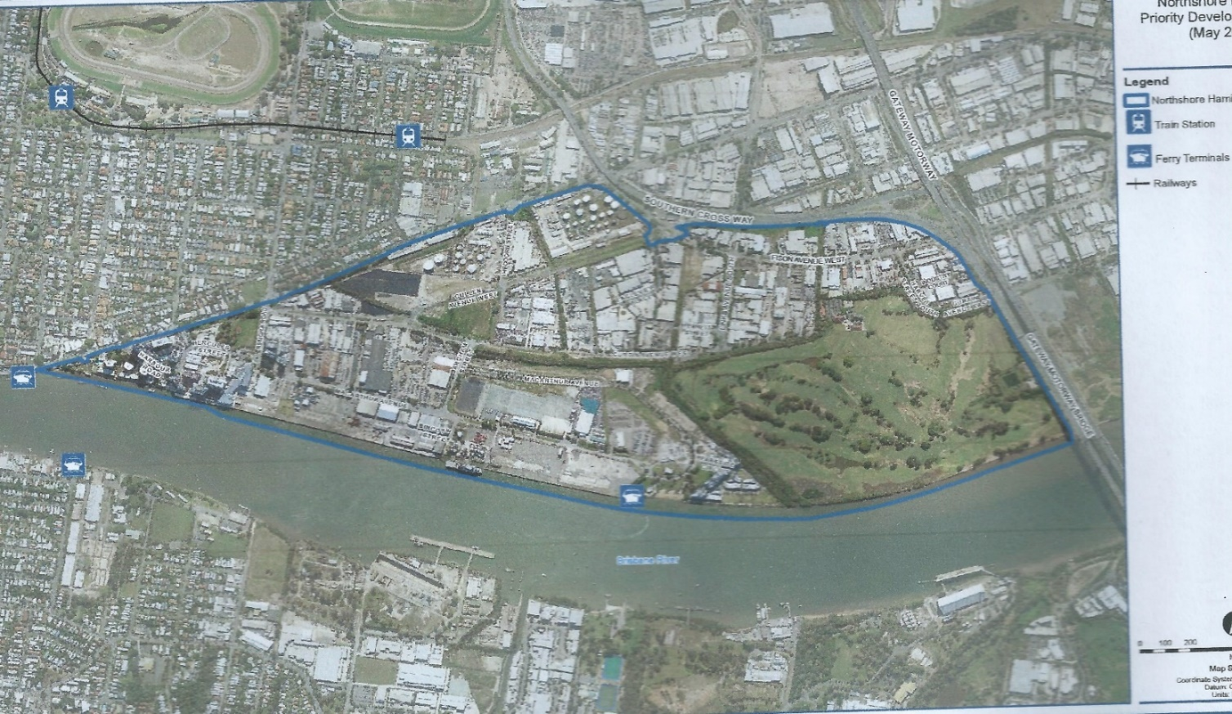
Pre 1820
Aboriginal society and Pre-european settlement

Aboriginal people of the Turrbal language group lived in Northshore and the area immediately surrounding it. They made good use of its rich natural resources and geographical features.

In the 1820’s, several Aboriginal camps were noticed by Europeans to the north of the Brisbane River. Figure 2 illustrates aboriginal camps and significant sites in the broader area. Camp D is within the Northshore area and was approximately located on the corner of Kingsford Smith Drive and Remora Road. There were at least two aboriginal camps at Breakfast Creek—with its fresh water, and on Eldernell Hill—a useful signalling place—to its north. The Breakfast Creek camp seems to have been the largest and most important camp site in the lower Brisbane River valley. On his first exploration of the Brisbane River in December 1823, the New South Wales Surveyor-General, John Oxley noted many beaten paths leading to the Breakfast Creek camps. In his second voyage along the river in 1824, Oxley encountered Aboriginal men who were fascinated by his surveying instruments.

The area provided ample food resources including fish, shellfish and the marine worm, known to the Aboriginal people as cobra. Native fresh water wells, lagoons and waterholes were also identified in the area. As ceremonial life was very important to aboriginal people, Northshore was the scene of tournaments and corroborees.
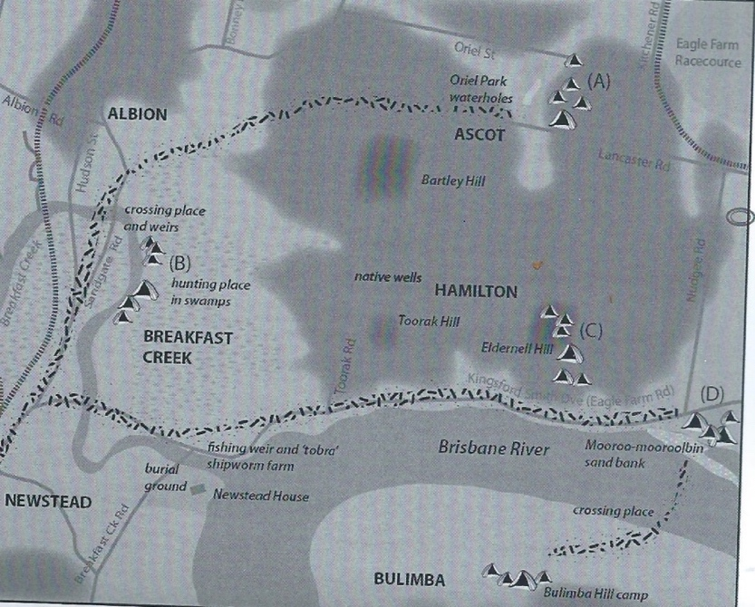
Significantly, the shallowness of the Brisbane River provided convenient places to cross the river at low tide. Figure 2 illustrates aboriginal pathways through the area, including a pathway along the river through Northshore (dotted lines). This is where Kingsford Smith Drive (or Eagle Farm Road as it was previously known), is located. The sandbank which became part of the reclamation area of Northshore was known as “Mooroo-mooroolbin” or ‘long nose’ by aboriginals.

Figure 2 Map of camp sites and other Aboriginal places within and near the Hamilton Northshore.

1820–1840

SUMMARY
John Oxley surveyed Moreton Bay and a penal colony was established. Sea (Hamilton) Reach was undeveloped and port activities were carried out in the city. Imports included stores and medical equipment and the key export was timber.

IN 1823, John Oxley, New South Wales Surveyor-General, explored and surveyed the Brisbane River and made several observations about Northshore and surrounds. He climbed Toorak Hill and could see Moreton Bay from that vantage point. He liked the area of Breakfast Creek and the stretch of river he named ‘Sea Reach’ (Hamilton Reach) and he suggested that Breakfast Creek be established as a new settlement.

‘I think a permanent settlement would be advantageously formed on the west side of the river at the termination of Sea Reach. The river here is not fresh, but there is plenty of fresh water. The country is open, and no obstacles exist from swamps or hills to prevent a ready communication with the interior either by the river itself or at a distance from it’. John Oxley— New South Wales Surveyor-General

In 1824, Governor Brisbane endorsed Oxley’s suggestion but in 1825, the first Commandant of the Moreton Bay penal colony, Henry Miller, moved the temporary convict base from Redcliffe to a new location considerably further. This location grew into the City of Brisbane with its administrative and commercial centre on the north side of the river, and its main port immediately opposite on the south side. In hindsight, Oxley’s choice would have allowed a more efficient port to be created.

The cultivation of food crops began in Brisbane to support the penal colony. Agriculture expanded and by 1826, the economic base of the Moreton Bay colony was mapped out—livestock, food crops, sugar and tropical crops, were to be expanded and the cultivation of cotton was advocated. Timber was also important, cedar and especially hoop pine (Brisbane River pine, Araucaria cunninghamii) and became a valuable national and international export resource.
In 1825, Lockyer discovered coal on the river bed at the present Kholo Crossing and noticed deposits in other places in the upper river. This was a significant moment as steamships required lots of coal and the steamer age was beginning.

In 1829, Charles Fraser, the Colonial Botanist, examined the region surrounding Brisbane town to expand agricultural uses. Fraser explored the north bank of the river between Toorak Hill and north-east of the islands in Sea [Hamilton] Reach. He found a fine stream [Serpentine Creek] of fresh water of excellent quality and land he considered suitable to grow rice and, in drier parts, wheat. He thought that this area was far superior to land closer to Brisbane due to ‘a great saving of water carriage’. This land became Eagle Farm. In 1829, female convicts were moved from the site of the present GPO in Queen Street to Eagle Farm. A road was hacked through the rocky bank to connect Eagle Farm to the centre of the settlement in Brisbane. It is thought that these women convicts built the first Hamilton Road—which became Breakfast Creek Road and Kingsford Smith Drive.

Eagle Farm and surrounding farms were generally productive in the early 1830s with maize and other products regularly exported to Sydney. The discovery of the Darling Downs, establishment of cattle stations at Redbank and Coopers Plains, and the penetration of the Macpherson Range—linking Moreton Bay to Northern Rivers, New South Wales increased both the potential for successful agriculture and the importance of Brisbane as an export centre.

The question of establishing an efficient port became more pressing— but the bar of the Brisbane River was too shallow to allow larger vessels in. A sand bar starting at Colmslie and stretching to Hamilton allowed people to walk across the river with the crossing only 3½ feet (1 metre) at its deepest, a situation which continued until 1873 when a flood increased the depth to 6 feet (1.83 metres).

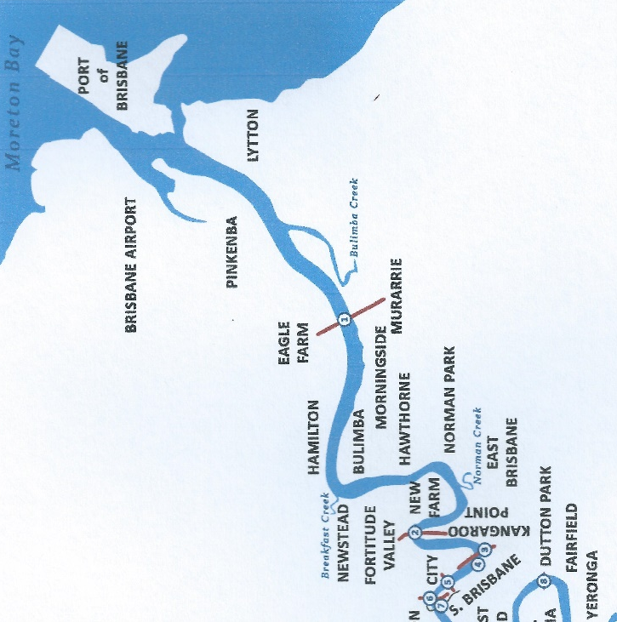
Figure 3 This modern map shows the difference between the comparatively straight Brisbane River as far as Breakfast Creek compared with the sharp meanders between there and the centre of Brisbane city.
Figure 4. A watercolour of Brisbane in 1835 by Henry Boucher Bowerman. The large building on the right is the Commissariat Store which housed supplies for the settlement unloaded at the Queen’s wharf in front of the store. Bigger ships soon began to moor on the other side of the river (Image State Library of Queensland)

1840–1860

SUMMARY
The Colony of Queensland was established, Moreton Bay district opened for free settlement, wool and beef became some of the key trading commodities and the Brisbane River bar prevented vessel movement.

In February 1842, Governor Gipps proclaimed the Moreton Bay district to be open to free settlers, but obstacles lay in the way of fulfilling the district’s potential. Wharf facilities at South Brisbane were so poor that a public subscription was opened to raise money to replace them as the New South Wales administration was reluctant to spend money on infrastructure in its northern outpost.

There was also disagreement about the location of a larger port—Kangaroo Point was emerging as better than South Brisbane for shipping—or Cleveland, as it had a deep-water port with potential connections to Ipswich for the trans-shipment of wool from the Darling Downs. Shipping interests came to the rescue of South Brisbane when the Hunter River Steam Navigation Company purchased land at South Brisbane where it intended to build a wharf and warehouse.

Despite frustrations over port facilities and annoyance that the administration in Sydney was reluctant to spend money on infrastructure projects in Moreton Bay, exports from Brisbane grew in the 1840s and manufactured goods had to be imported. The growth of trade from £72,000 in 1847 to £355,000 in 1857, could not be ignored.

In 1844–5, 2,313 bales of wool, 806 casks of tallow and 1,587 hides as well as salt beef, sheepskins, pine logs and small amounts of cheese were exported from Brisbane.

In 1844, Brisbane was declared a port of entry for overseas shipping, the first step in the development of a modern port. The shallow bar and the Eagle Farm ‘flats’ continued to impede Brisbane’s development as a port. Nevertheless, commercial wharves were developed at Kangaroo Point, Petrie Bight (sharp reach of Brisbane River, area under northern part of Storey Bridge and near Customs house) and north and south Brisbane in the 1850s. Brisbane was developing as a warehouse centre and a port for the transhipment of imports and exports.

Coal, discovered along the Brisbane River in 1825, came into focus in the 1840s. In 1843, the Hunter River Steam Navigation Company opened its regular return service between Sydney and Brisbane. The local Brisbane entrepreneur, John Williams, opened the first coal mine at Redbank and later at Moggill and in 1846 a regular paddle steam service between Brisbane and Ipswich commenced.

The need to improve the shallow river bar so that larger ships could enter the river port was a key issue in Brisbane’s struggle for independence from New South Wales which persisted through the 1850s until success was finally achieved in 1859 when Queensland became a separate colony with Brisbane as its capital (named after its first Governor).

Image 6 The little town of Brisbane in 1860 photographed from the heights of Wickham Terrace looking towards South Brisbane. The Brisbane River stands out as neatly bisecting the city. (Image State Library of Queensland)

Image 5 Paddle steamers remained a common sight on the Brisbane River for decades. The Queensland government side-wheeler, Lucinda, is shown here complete with decorations. (Image State Library of Queensland)
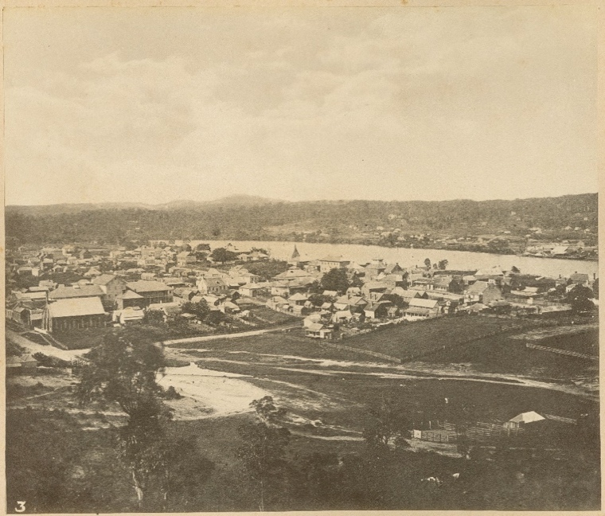
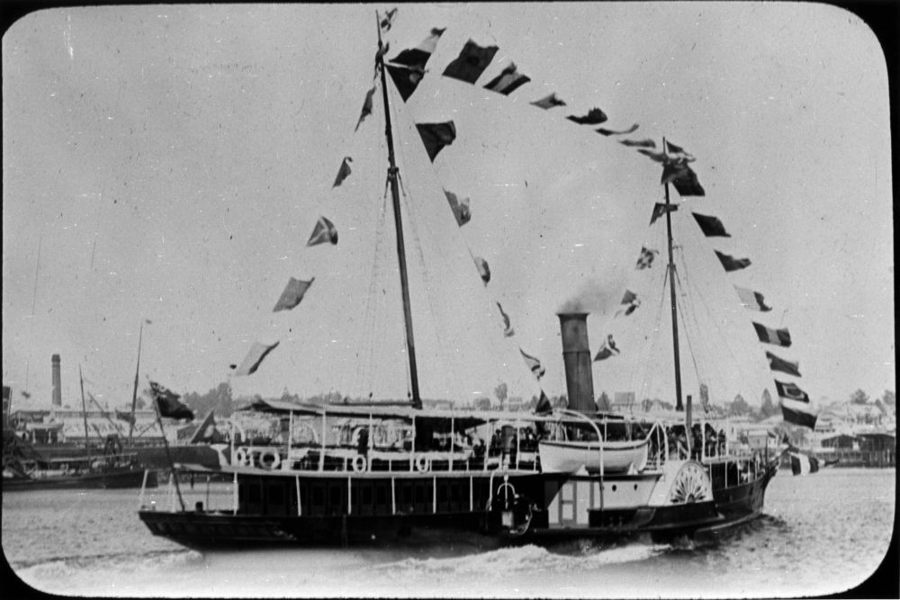
1860–1880

SUMMARY
Port growth required continual dredging to keep the navigation channels open and operational. Sport was a powerful driver of infrastructure development as the Eagle Farm racecourse and Hamilton Hotel opened and the area became the pleasure boat destination with its own wharf.

When Queensland became independent in 1859, its government controlled the port and its operations, a considerable departure from the usual practice of entrusting such matters to the local government. Brisbane City Council did, however, control the river frontage in Eagle Street and Petrie Bight which became wharfage areas in the 1860s. In the 1860s, improving access to the port was essential particularly as steamships became larger and larger and new channels were dredged to deepen channels through the troublesome bar. Trade increased and exports grew from £435,744 in 1860 to £910,750 in 1869.

In 1863, Brisbane’s main race course in New Farm relocated to the northern end of the present Racecourse Road and stimulated a range of development. In 1864, the Hamilton Hotel was built by Gustav Hamilton, a Brisbane solicitor, and opened to cater for race patrons. “The Hamilton, as its patrons called it, gave the area its name. A small wharf was constructed at the end of the original Racecourse Road to cater for craft bringing patrons to the races.

Yachting became a very popular pastime on the Hamilton Reach and in 1865, a regatta was designed to increase patronage at the Hamilton Hotel. The boat races were conducted with more enthusiasm than expertise, in the opinion of a newspaper reporter. Hamilton was also the destination of pleasure boats taking patrons to the races as early as 1867, a practice which continued at least until the 1880s.

In 1869, the 381-ton barque, Cabot, loaded goods destined for London at Hamilton and by the 1870s, the Hamilton Wharf had become a landing place for a ferry connection to Bulimba, a growing shipping area directly across the river.

And it’s no wonder patrons came by boat, the main road to Hamilton from the city, Hamilton Road, as it was called for nearly a century (now Kingsford Smith Drive) had remained a rather primitive bush track, built by convict labour, and it was decades before it became a satisfactory road, as this notice from a newspaper in 1865 indicates:
‘A notice has been issued by the Commissioner of Police, with the view of preventing accidents on the road to the [race] course during the three days' races. It is to the effect that between Breakfast Creek Bridge and the Hamilton Hotel no vehicle or horseman going to or returning from the race-course will be allowed to pass another going in the same direction and constables will be stationed along the road to see the regulation carried out. Drivers of vehicle and horsemen will have to pull up to a walking pace when required to do so’.

From 1871 to 1877, the river was widened and deepened, and a number of channels were created including the Francis Channel, No 1 Channel below Hamilton, and No 2 Cutting between Queensport and Hamilton. The infamous Lytton and Groper Dredges worked for many years to permanently deepen the river to 15 feet (4.57 metres) below low water and widened the river channels to 250 feet (76.2 metres).

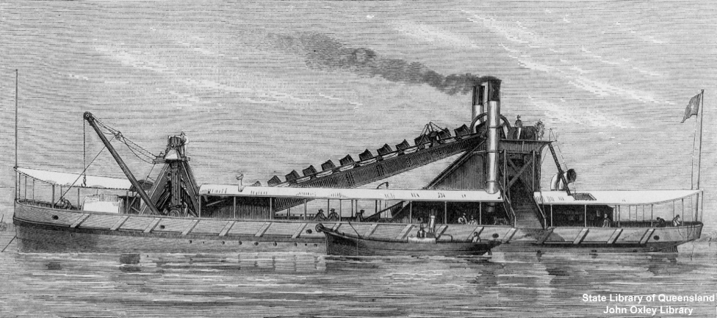
Figure 7 In this 1877 sketch, the dredge, Groper, is working in the Brisbane River. (Image State Library of Queensland)

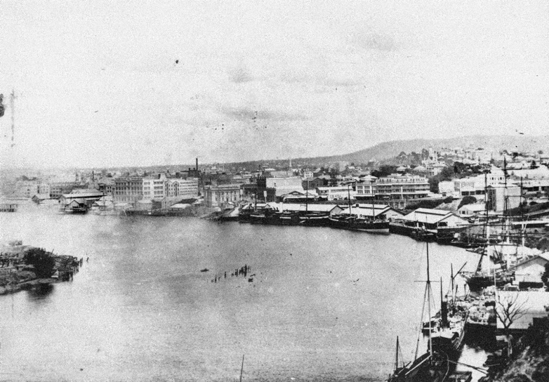
Figure 8 Ships moored bow to stern at Petrie Bight in 1895, showing that even the new 1880s wharves had rapidly become congested. (Image State Library of Queensland)

1880–1900

SUMMARY
Hamilton continues to grow as suburb and recreation destination, an engineering scheme is hatched to tame the river and reclaim land, new public transport arrives, and Hamilton became its own local government area. The depression years of the 1890s slowed the economy, but revival was underway by end of the decade. Floods inundate Brisbane and river dredging is increased to enable coal to be exported from river wharves.

The population of the Hamilton and Ascot district boomed in the 1880s when several estates of residential property were marketed. Previously, the residents of this area had been wealthy community leaders who constructed large houses with extensive gardens. These residents constantly agitated for improvements to Hamilton Road (now Breakfast Creek Road and Kingsford Smith Drive) which was still only a rough track in 1882. They lobbied for a retaining wall to be built—as ‘the road had become dangerous in parts owing to the constant wash of the river on the bank’. The Toombul Divisional Board, the local government for the area, was continually petitioned for modern conveniences like gas lights along Hamilton and Nudgee Roads at the Hamilton Wharf.

In 1882, the railway line reached Pinkenba, which was to become a trading hub, and a three-kilometre railway spur was built to Ascot for the convenience of race patrons. An extension of the electric tram service from Breakfast Creek along Hamilton Road opened in the late 1890s, replacing horse-drawn trams and after years of argument about the wisdom and financial viability of a tram service.

The introduction of better transport accelerated development of the Hamilton area and marketing of the Hamilton Reach Estate took advantage of improved transport, communications and river attractions. The Hamilton Local Government Divisional Board was established in 1890.

As the size and tonnage of ships increased, they could only navigate as far as Breakfast Creek. Tugs would then bring them to the wharves at North or South Brisbane. Adequate wharfage for bigger ships in the city was becoming insufficient and more land was sought downstream. And so, dredging the river for larger ships continued. Local places for dredge spoil were running out and the dumping of dredge spoil continued on Mud Island in Moreton Bay, becoming an expensive solution. To add to this, floods in 1887, 1890 and 1893 washed material down river and filled the dredged channels reducing them by 3 feet (1 metre), to a minimum depth of 15 feet (4.57 metres) and deposited dangerous snags. Silting in the Hamilton Reach was the worst.

In 1897, realising the futility of dredging alone, the chief engineer of Harbours and Marine, Ernest Alexander Cullen, proposed an ambitious scheme to improve the situation. After surveying, studying and reporting on the river and its main cuttings: Eagle Farm Flats, Quarries Reach and Hamilton Reach, he proposed complex engineering work to train and regulate the lower river. He recommended constructing training walls at Hamilton, cutting off some sharp points and additional dredging. His scheme also offered a solution to another growing problem—dredge spoil—and he recommended it be pumped ashore behind the new training walls to avoid the expense of carting the spoil into Moreton Bay. Effectively he planned for the creation of the area now known as Northshore. He also urged the government to use this land and buy surrounding land and for future industrial land.

Implementation of the scheme began in 1898 with the commencement of the construction of the Hamilton Training Wall, it followed the line of the “Hamilton Sandbank”. The wall was completed in September 1900 and was expected to cost £23,000. Construction started opposite the Hamilton Hotel and extended downstream for a distance of about 2,500 metres. Rock dredged from the Lytton cutting was deposited to form the foundation. The wall was planned to be of ‘random’ stone quarried from the Kangaroo Point cliffs and brought to Hamilton in barges. The wall was to be 1.3 metres wide at the top with a ‘natural slope’. The wall crossed a sand bank and a trench between 6 and 2.43 metres deep was cut through the sand bank.

The construction employed 70 men with 3 punts drawn from the quarry by the Albatross. The wall was 8,600 feet (2,621 metres) long and contained 106,400 tons of stone. Other walls on the river were also constructed, and all of them,Doughboy, Coxen Point, Bulwer, Parker Island, Lytton had the desired effect of maintaining the dredged channels. However, vandals stole the stone for their own home gardens and coupled with a rat infestation, the Hamilton Wall was eventually grouted. Dredging continued and by 1899, the river had been deepened to 20 feet (6.1 metres) below low water for a width of 200 feet (60.1 metres).

Recreation continued to be important theme—Cricket was played at Hamilton and the sailing regattas became more sophisticated by the 1880s—the government steamer Kate, on at least one occasion, moored in Hamilton Reach so that enthusiasts could watch the racing. The Hamilton Training Wall became a popular and convenient vantage point to watch the regattas and by the late 1890’s Hamilton Reach, and the whole lower riverwere favourite places for recreation including sailing, swimming, boating and visiting the amazing Queensport Aquarium. The aquarium, located across the river at Hemmant, was Queensland’s first theme park and opened in 1889. It featured sea creatures, a zoo with exotic animals including tigers, monkeys, birds and bears. It had a roller coaster, an enormous dance hall with bands and the steamer Natone took visitors from the city to the aquarium as a package deal.

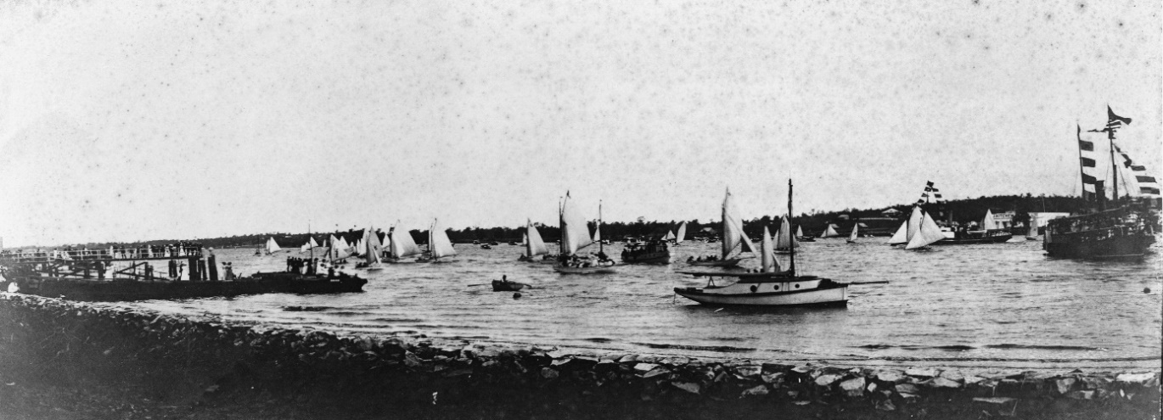
Image 24 By 1910, ‘Henley’ regatta days on the Hamilton Reach attracted many yachts and large numbers of spectators on shore and on the flag ship (at right). Image: State Library of Queensland

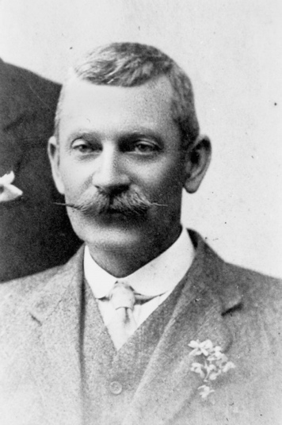

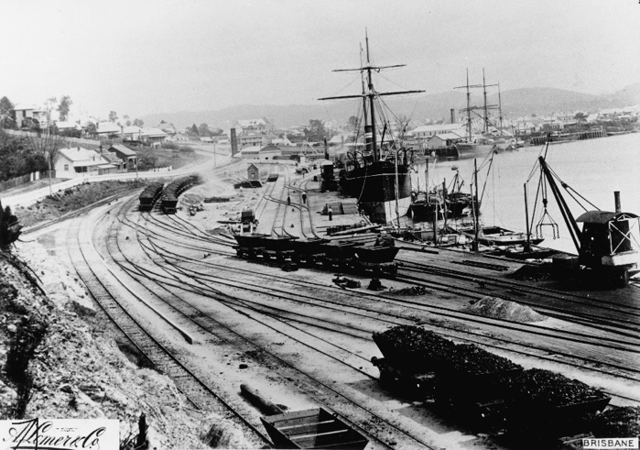
Figure 12 Coal was brought by rail from Ipswich to the South Brisbane coal wharves, pictured here in 1889. (Image: State Library of Queensland)

Image 9 Ernest Alexander Cullen—Brisbane’s port visionary and NorthShore’s first developer. Cullen Avenue is named in his honour.
(Image: State Library of Queensland)

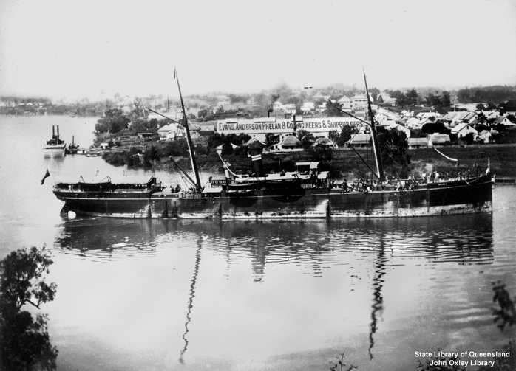

Figure 11 The length of the ship Bulimba indicates the difficulty big ships found in navigating sharp points in the Brisbane River. Bulimba was passing Kangaroo Point shortly after Evans Anderson Phelan located their works there in the mid-1880s.(Image: State Library of Queensland)

1900 - 1920

SUMMARY
Hamilton becomes a town, Hamilton Training Wall is completed, dredging continued to enable larger vessels to access ports. Land is reclaimed and acquired behind the wall, the area now known as Northshore, for future port and industrial uses. New wharves are built in Bulimba, New Farm and Hamilton to cater for the growing need for imported goods for industry, retail and domestic use as well as the growing export of primary produce, butter, meat, wool, boosting the Queensland economy. 1914–1918 saw World War I.

The opening of markets in Britain for perishable goods such as butter and meat facilitated the construction of wharf facilities on both sides of the lower river. The Dalgetys Wharf was built along the Bulimba Reach, Wharves and Wool Dumping Co built a cargo handling complex at New Farm. In 1903, vessels drawing 26 feet (8 m) could reach Pinkenba at any high tide. In 1918 overseas trade from Brisbane included imports of £4,237,009 and exports of £7,832,967.

In 1904, Hamilton became a town and in 1906, the Hamilton Training Wall height was increased to 3.04 metres above high water. Land reclamation behind the wall required 17 million cubic yards (14,214,159 cubic metres) of dredged material over 17 years. An area of 750 acres (304 hectares) behind the training walls between Hamilton and Pinkenba was purchased to provide room for future development. ‘In view of the increase in the volume of trade and of the size of ships…it has been recognised that provision should be made for additional [port] accommodation, and accordingly an area of 840 acres [340 hectares] of land has been resumed at the Hamilton Reach….which will afford an ample area for development’. Plans being prepared for the development of a ‘basin’ at Hamilton would show accommodation for vessels up to 850 feet (259 metres) long. The linear extent of the quay was to be 26,000 feet (7924.8 metres) to be constructed in sections and in direct communication with the railway system’.

Newly arrived immigrants spent time at the quarantine station near Fort Lytton which played an important part in the defence of the river and in 1914, troops left Pinkenba Wharf for service in World War I, as they had for the Boer War. The soldiers aboard the Omrah at Pinkenba in 1914 were among the first to serve at Gallipoli.

Popular recreational areas continued to be developed in the lower river. The dredge making a new cutting from Lytton into the Bay threw up a great deal of sand on the starboard side forming a large bank has been formed which became a favourite picnic spot. The local paper suggested that tropical trees such as coconut palms should be planted. The Friend family opened a kiosk on Gibson Island in 1919 and Bishop Island, formed by dredge spoil, attracted pleasure-seekers for stopovers on the way to the Crouch family’s holiday cabins on Bishop Island.

In 1919, immediately after the cessation of World War I hostilities, the Queensland Government announced that it would construct new cold stores and a wharf for butter and cheese destined for Britain. The government retained most of the riverside land at Hamilton (Northshore) and became the construction authority and owner of the new Cold Stores Wharf and storage facilities. The complex was to be close to the turn of the Ascot tram line from Hamilton Road into Racecourse Road. There were also opportunities for expansion at this site and it was estimated that the stores would cost about £200,000.

Image 21 This 1917 plan for the Riverview Estate demonstrates the mixture of small allotments and the large land holdings of prominent citizens which characterised Hamilton and began in the 1880s boom years. The kiosk marked on the lower right of this plan was located in the Reserve which caused such anguish when Brett’s Wharf was extended. The original line of Racecourse Road leading to the River is also shown. Image: State Library of Queensland

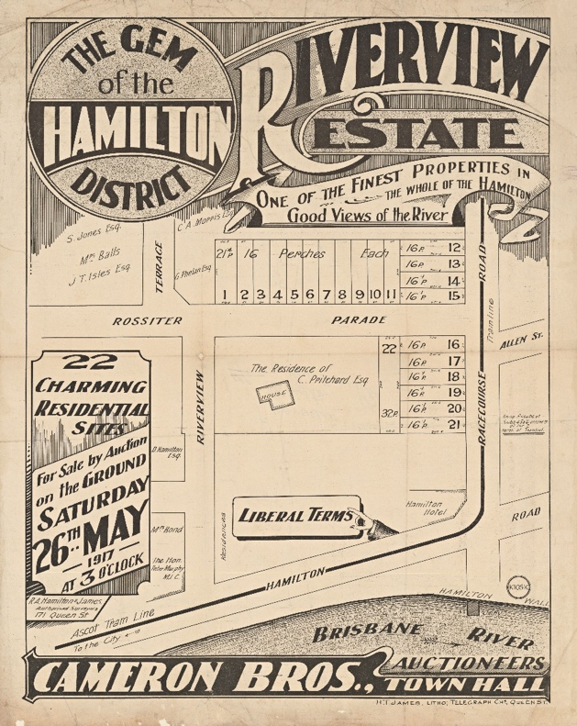
Image 10 The Hamilton Training Wall served more than one purpose. Here, a crowd on the wall is watching a sailing regatta in 1905 (Image: State Library of Queensland)

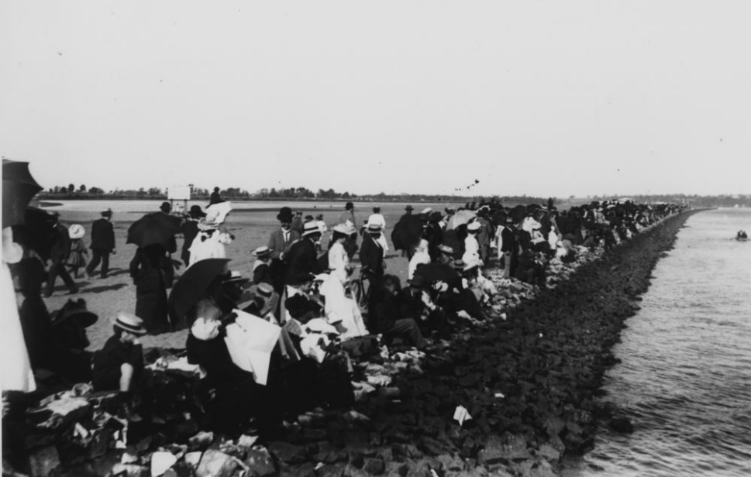
1920 - 1940

SUMMARY
The Royal Queensland Golf Club was established, Doomben Racecourse opened, Hamilton port expanded with construction of the Cold Stores and Brett’s Wharf. The Training Walls were extended from Hamilton down to Pinkenba and reclamation of the land behind the new walls commenced. Additional wharves were built and used for wool, cattle trading and cold storage facilities, World War II (WW2) commenced (1939-1945) and the first aerodrome opened in Eagle Farm.

The Royal Queensland Golf Club (initially the Queensland Golf Club) was built upon swampy land reclaimed by dredged sand in previous years. The course was designed by the then Australian Open Golf champion, Carneigie Clark and on 1 September 1920, the Club was granted a 30 year lease of 400 acres (162 hectares) ‘for special purposes (golf links)’. A condition of the lease allowed for resumption of a strip of foreshore for harbour purposes (wharf expansion, roads and rail). The government was determined to expand the port and the Club was told that its lease would not be extended past 1966. These fears faded as planning for a new port at Fisherman Island commenced and, in 1977, the Club was granted a lease for 75 years. The Club received its ‘Royal Charter’ in 1921 with a letter from King George and signed by Winston Churchill.

Doomben racecourse opened in 1933 but was closed and used by allied troops during WW2, opening again in 1946. The river continued to be a popular recreational destination including swimming in Serpentine Creek and rowing to Gibson Island. Rowing crews competed for the King’s Cup on Hamilton Reach in 1939. The Friend family tourist facilities operated on Gibson Island and the Crouch family built holiday cabins on Bishop Island (land reclaimed by dredge material and now part of the mainland at Port of Brisbane) and operated a ferris wheel and dance hall.

In 1921 Brisbane’s population was 217,714 and overseas trade included imports of £7,217,961 and exports totalling £13,924,462. Exports included wool, frozen meat, butter, hides, tallow and minerals and perishable exports catered for by five modern large freezing facilities. A total of £2,332,977 had been spent on port improvement works up to June 1920, including the resumption of land between Hamilton and Pinkenba.

A Cold Stores Wharf was built at Hamilton and was the major catalyst to wharf development in Hamilton. The cold stores were a vital centre for the export of Queensland butter to Britain and was constructed in 1922. The complex included a rail link to the main Whinstanes railway junction at Eagle Farm as these connections became increasingly significant. However, this did little to alleviate the shortage of wharf accommodation in Brisbane. Nevertheless, the Cold Stores Wharf was a major breakthrough in shifting the port downstream. Port development was, however, impeded by the government’s reluctance to appoint an administrative body, such as a Harbour Board, to concentrate exclusively on improving and managing the port.

The 1920s were vigorous years for construction and although Queensland had ample supplies of native hardwoods softwoods were scarcer. In fact, three-quarters of Queensland’s natural pine supplies were exhausted, and some forests replaced by farms. The Forestry Department embarked on reafforestation and new plantations but, until those trees matured, imports of pine soared. Responding to this need, the Brett family’s timber and hardware business provided materials for industrial, commercial and domestic construction and in the 1920s they began importing softwoods Douglas fir and Oregon pine for joinery manufacture, hardware retailing and property development.

In 1928, the Queensland Government leased land with 304 metres of river frontage adjoining the Cold Store Wharf to Brett’s. In 1929, a government Order-in-Council permitted the construction of a new wharf for Brett’s Wharves and Stevedoring Company Ltd.

In 1928, E A Cullen prepared plans and specifications for Bretts Wharf. It was to be suitable for the largest ocean-going ships, be the same level as the Cold Stores Wharf and designed to carry two lines of railway tracks to connect with proposed tracks on Cold Stores Wharf. Provision was to be made for the storage and handling of general cargo, including wool and large quantities of timber. Cullen recommended timber for the construction of the wharf as it would last 30 years, be cheaper and quicker to build and was more elastic and able to cope with stresses caused by the wash of passing ships.

However, it was to be reinforced with concrete pile-sheathing manufactured in Brisbane by the Hume Pipe Company and this gave extra protection from marine borers.

In 1928, Taylor Bros of Brisbane won the construction contract and the first pile was driven on 16 January 1929. The contract was completed on time at a cost of £32,553 and the first ship berthed on 26 July 1929the Texas Oil Company’s Australia of 17,237 tonnes. The wharf was equipped with two electric cranes and by late 1929, three very large fully loaded ships could be handled without difficulty at the wharf.

The quay structure was 30.5 metres wide and the Wharf was 18.28 metres x 30.5 metres. Two sheds each were constructed at the back of the wharf with an unroofed section to store timber and heavy cargo. Wharf timber included grey ironbark, Eucalyptus paniculate for piles in the riverbed, red bloodwood, Eucalyptus corymgbosa for piles inside the line. These timbers were chosen to be resistant to white ants and marine borers, Teredo navalis and Limnoria indicus, active in the Brisbane River. The decking was brush box, Tristania conferia, a hard and durable timber and Fraser Island ‘turpentine’, Syncarpia laurifoilia (now known as Syncarpia glomulifera), was used for the fender piles.

In 1929, despite recording heavy losses, the Hamilton Cold Stores were extended following complaints by dairy farmers claiming that the cold stores and the wharf were inadequate.

In 1932, the Platypus dredge deepened the bar to 30 feet (9 metres) as a first step in creating even deeper channels to Hamilton. The Apollo Ferry crossed between Hamilton and Bulimba and in 1934, the Brisbane Stevedoring and Wool Dumping Company Ltd leased 1,100 feet (336 metres) of river frontage with adjacent reclaimed land and by 1937, they had constructed 1,000 feet (334.25 metres) of wharves at Hamilton.

The work on the bar, the construction of Brett’s Wharf and further work to create a more effective port provided much needed employment during the 1930s economic depression. By 1937, nearly all the 144 acres of reclaimed land at Hamilton was above highwater level. Constant maintenance was needed as the reclaimed land subsided when water was squeezed out by subsequent loads.

Tensions increased between local residents and industry as the port was extended. Brisbane City Council sold a small public park, Hamilton Reserve located on the corner of Racecourse Road and Hamilton Road [Kingsford Smith Drive]—to facilitate Brett’s Wharf extension, and, it also closed the river end of Racecourse Road which led to the Hamilton ferry. This was controversial and highly criticised by local residents and the press.

In 1922, the women convict barracks at Eagle Farm was acquired by the Commonwealth Government to develop an airport. In 1923 a grass airstrip was formed, and QANTAS commenced the first commercial operations. In 1927 QANTAS established the Brisbane Flying Training School. Significant aviation events occurred at Eagle Farm airstrip, on 9 June 1928 Charles Kingsford-Smith, born in Hamilton and Charles Ulm completed the first trans-Pacific flight from California to Brisbane landing the Southern Cross at Eagle Farm in front of a crowd of 25,000. In 1929 they formed the Australian National Airlines and initiated scheduled services between Melbourne, Sydney and Brisbane. Hamilton and Eagle Farm roads were renamed Kingsford-Smith Drive after the legendary Charles Kingsford-Smith. In 1928, Brisbane City Council approved 228 acres (93 hectares) of farm land at Coopers Plains (renamed Archerfield) as the site for a new Brisbane aerodrome, replacing Eagle Farm Aerodrome, after suffering substantial flooding.

During the WW2, diversion of port maintenance and construction equipment to more urgent war purposes interrupted normal commercial activity and development. Government attention was focused on the capability of the Port of Brisbane to serve military purposes. The major wartime construction authority, the Allied Works Council, spent more than £2,000,000, an enormous sum in the 1940sto increase available berths at Hamilton and further downstream.
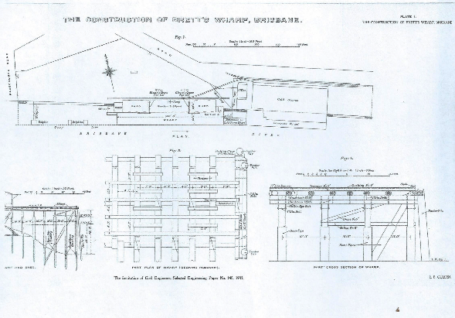
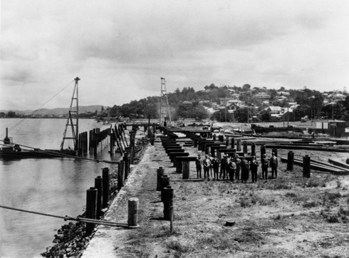
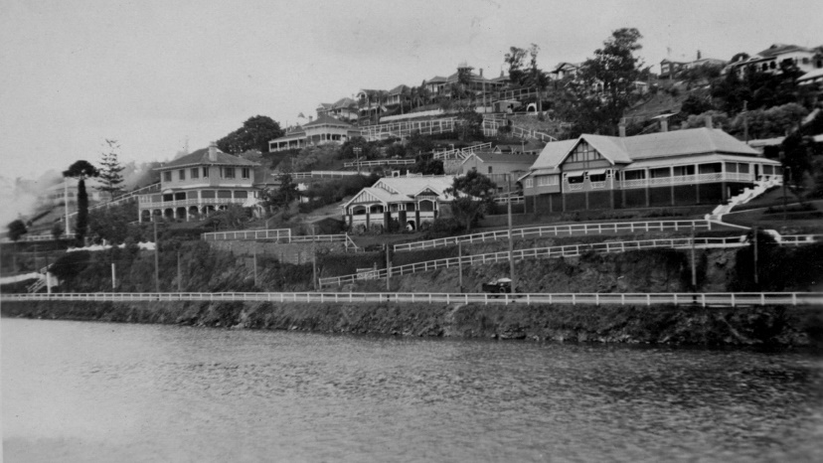

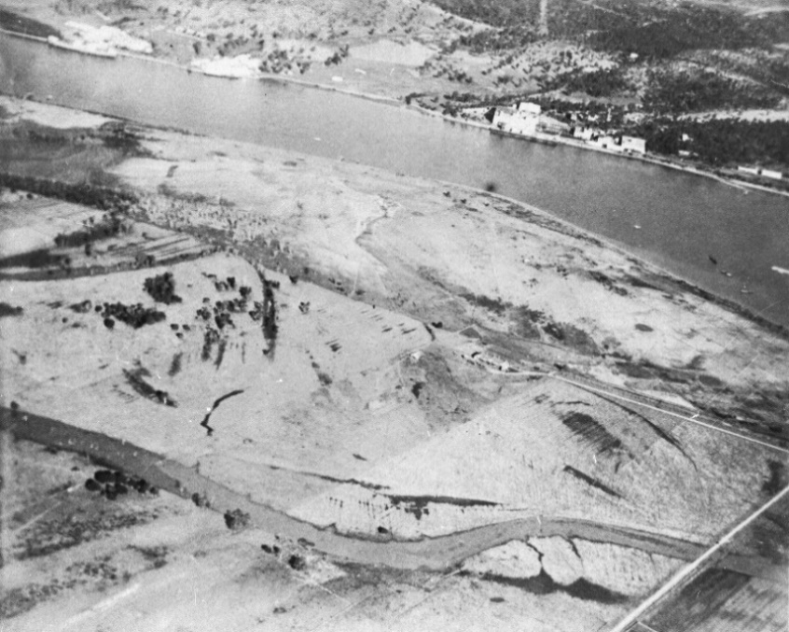

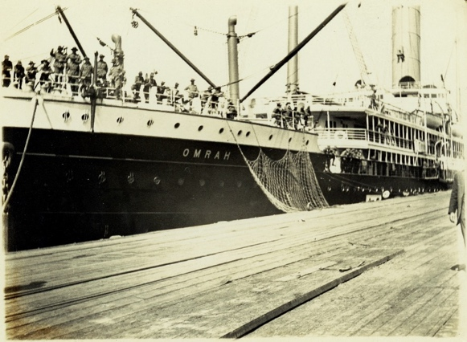
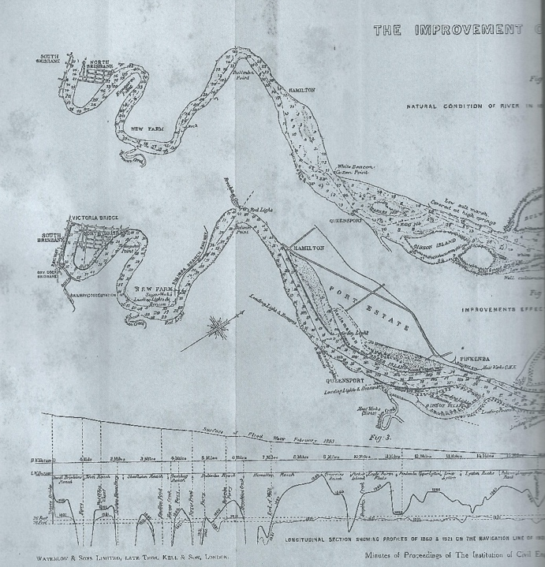

Image 17 Brett’s Wharf under construction in 1929 (Image State Library of Queensland)
Image 18 E A Cullen’s plans for Brett’s wharf as depicted in E B Cullen’s account of the wharf’s construction

Image 25 Almost ready for golf. An aerial photo of the Royal Queensland Golf Club in 1925. (Image State Library of Queensland

Image 20 Large houses on Hamilton Hill in the mid-1920s. (Image State Library of Queensland)

Image14 Cullen’s plan for reclamation as it appeared in his 1921 report.

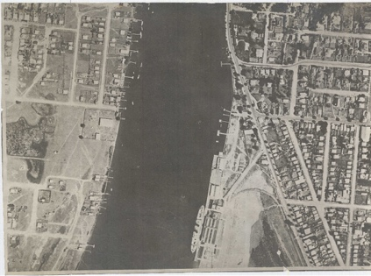
Image 15 The Wangaratta loading at the Hamilton Cold Stores Wharf in 1925 the concrete stores
are clearly visible. Concrete construction became more economical in Brisbane after cement works opened at Darra, post World War I era. The sloping training wall is also visible. (Image: State Library of Queensland)

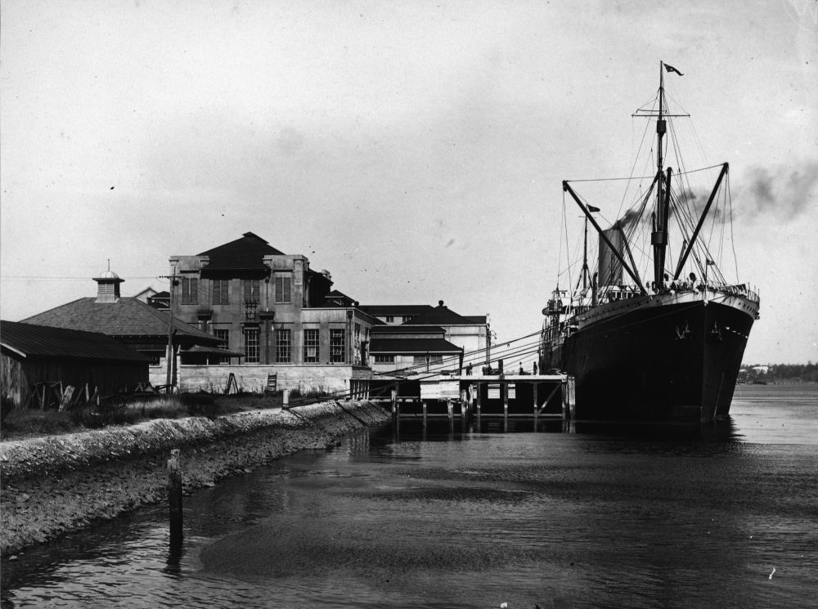
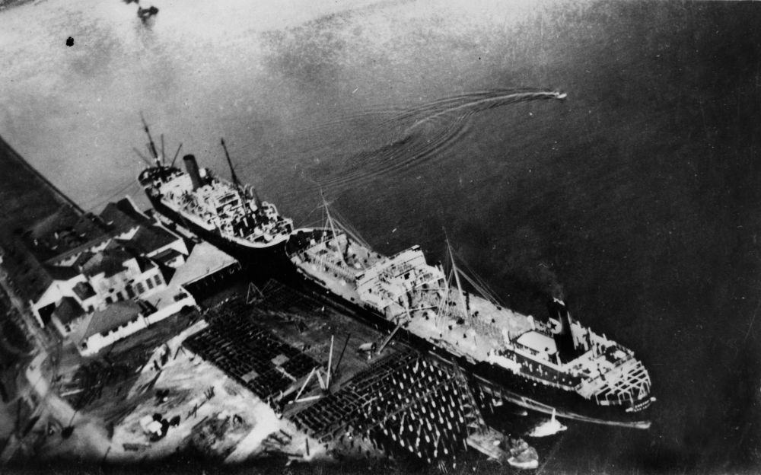
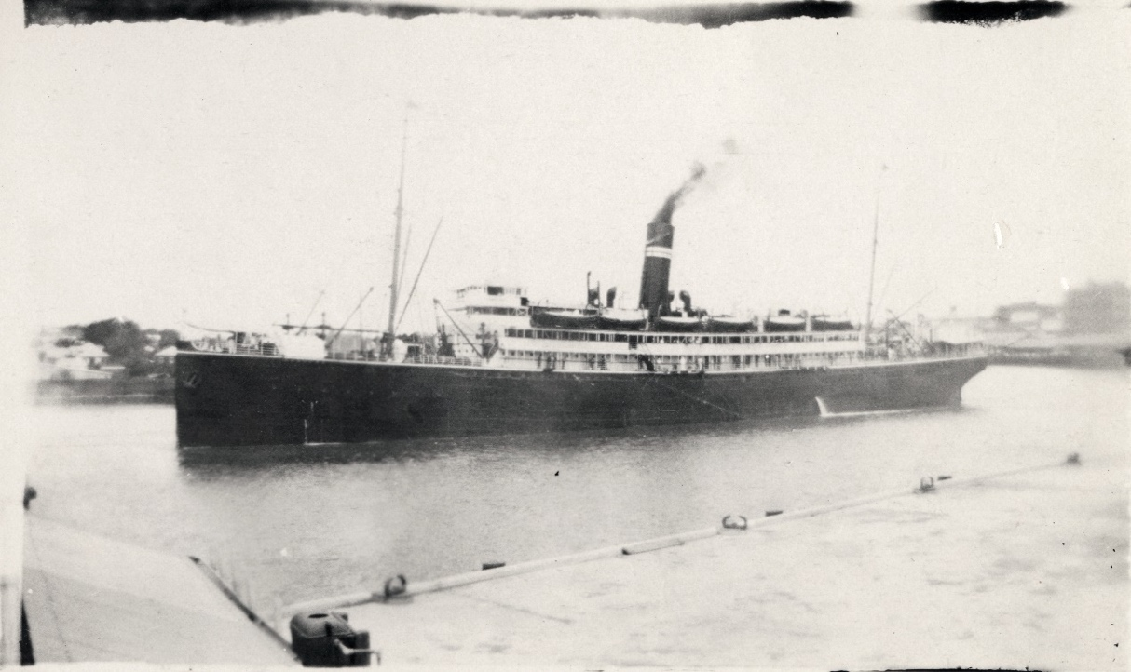
Image 16 Two ships at the Cold Store Wharf in 1929. Further construction is shown in the foreground. (Image State Library of Queensland

Image 19 The large steam Kanowna in the Brisbane River in the mid-1920s. (Image State Library of Queensland)

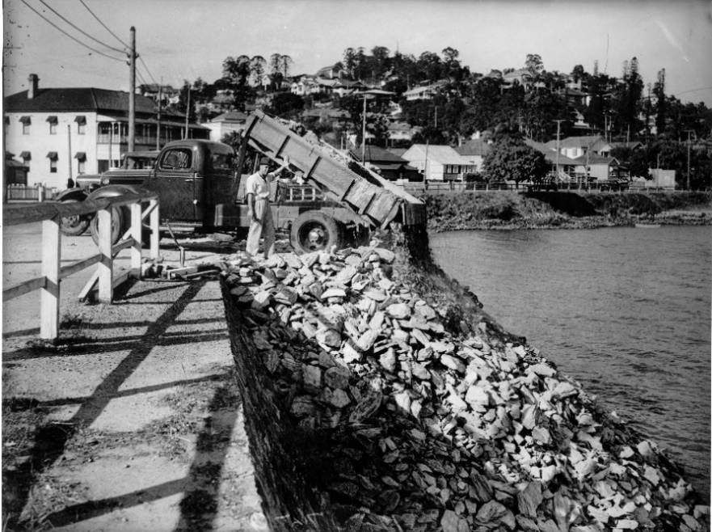
Image 27 This 1940 aerial photo of Bretts Wharf shows a ship at the wharf and, at bottom right, the progress which had made on reclamation work. (Image National Archives of Australia)

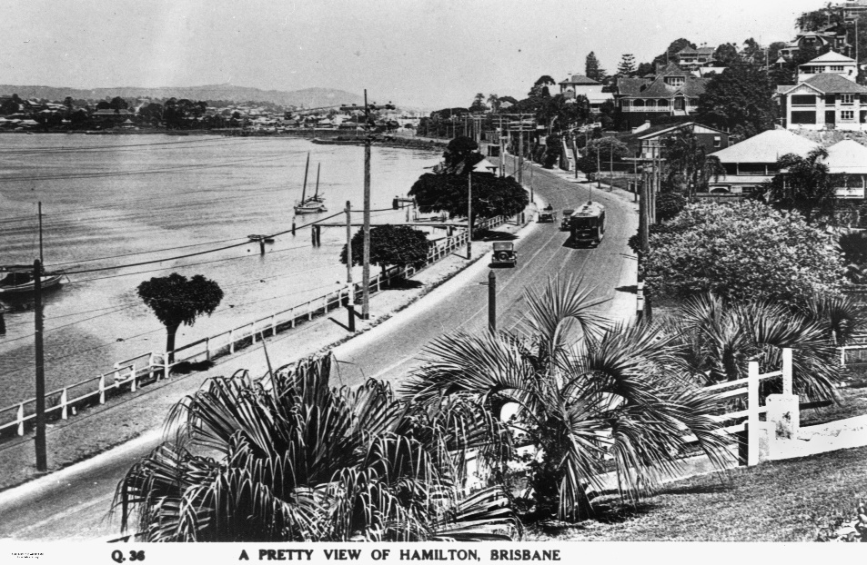
Image 22. Relief at last. Construction of the Kingsford Smith Drive retaining wall in 1935 (Image State Library of Queensland)

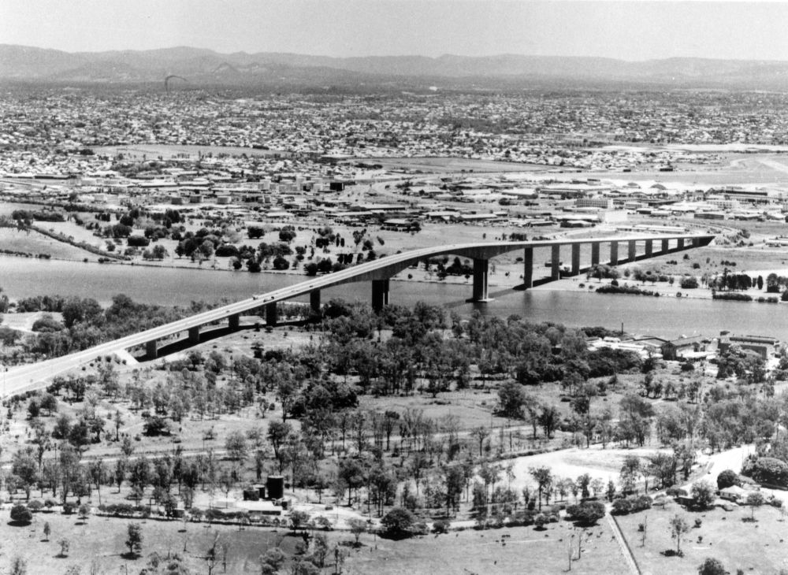
Image 23 Hamilton had become sophisticated by 1928, as shown in this photo of houses, a tram and cars on Kingsford Smith Drive. Image State Library of Queensland

Image 26 The first Gateway Bridge ready for its opening in 1986 with the Royal Queensland Golf Club’s links in the foreground. (Image State Library of Queensland)

Image 34 This contour plan of the area adjacent to Bretts Wharf shows the position of the Cold Stores and a wool appraisement centre. Remora Road, named for one of the dredges which worked in the river, is also shown. Police and Fire Brigade reserves are shown on the corner of Kingsford Smith Drive. (Image J1018 LS 722 National Archives of Australia)

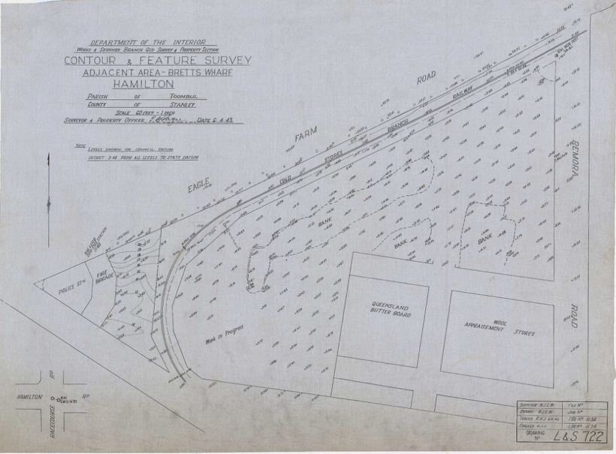
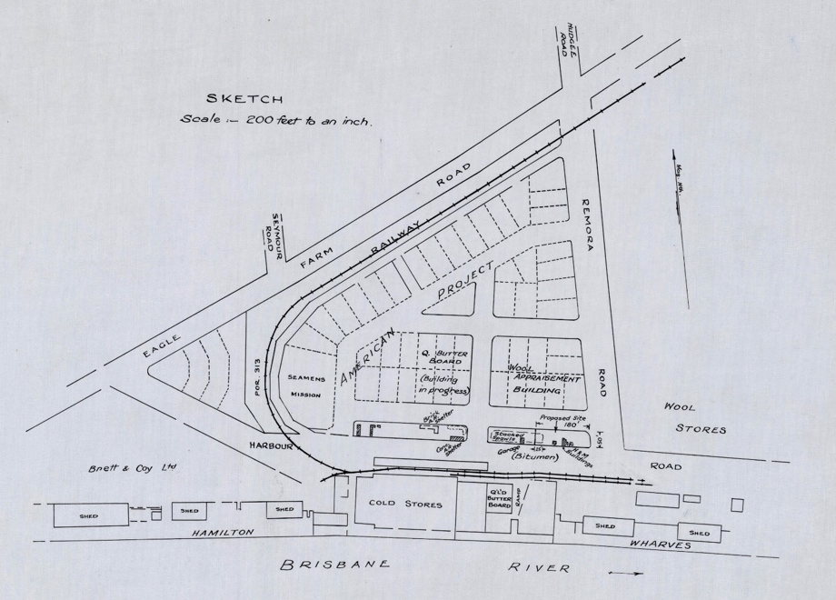

Image 40 The Hamilton Wharves and associated structures in 1975. (Image National Archives of Australia)

1940—1960
SUMMARY
During WW2 Hamilton and Eagle Farm were used for war purposes USA base camps, aircraft depot and airport, despatching war materials and naval base. Post WW2, the port grew as trade increased with the export of grain, sugar, live sheep and petroleum. Brisbane had become a major port by the end of the 1940s.

In 1940, a flying boat base located at Pinkenba was moved to Hamilton and constructed on the training wall downstream from the B.S. & W.D. Co. wharves. During World War Two, the Royal Australian Air Force (RAAF) used this base. Following the end of the war, a passenger terminal was constructed and two commercial operators, Qantas and Barrier Reef Airways, used the base for passenger flights to the Great Barrier Reef. Qantas ceased using the base in 1949, leaving Barrier Reef Airways as the sole operator.
However, the flying boat operations represented a danger to shipping at the Hamilton Reach of the river. According to a 1948 memo, this had been recognised as early as 1945 (BP292/1 214/108/1 Part 1, A. Hepburn for Director-General of Civil Aviation to District Superintendent, Department of Civil Aviation, 13 January 1948). The Department of Harbours and Marine submitted a formal complaint to the Department of Civil Aviation in 1949 claiming that the operations also delayed shipping in the area (BP292/1 214/108/1 Part 1, Chief Administration Officer and Secretary, Department of Harbours and Marine, to The Officer in Charge, Department of Civil Aviation, 15 August 1949). However, it was a change in dredging operations that eventually forced the relocation of the base back to Pinkenba in 1951 (BP292/1 214/108/1 Part 2, A.V. Lauchland, Airport Manager, Department of Civil Aviation, Government Aerodrome, Eagle Farm, to Regional Director, Eagle Farm, 6 November 1951).

In 1940, the Story Bridge, a government economic development project, was completed. In the same year, Eagle Farm aerodrome was taken over by the Royal Australian Air Force (RAAF) as a training base and became a United States of America (USA) base. American servicemen and their equipment began arriving in Brisbane in December 1941. The lower river and the surrounding suburbs became critical parts of wartime infrastructure. Aircraft arrived in crates on board ships and were assembled at Eagle Farm, which became a major aircraft erection depot and aerodrome for aircraft movement. One of the hangars from those hectic days remained on the site of the ‘old’ Eagle Farm airport.

Naval use of the Hamilton Wharves became much more common after 1939 when the HMAS Hobart arrived at Brett’s Wharf. Reclaimed land at Hamilton was used extensively by the USA Army and Navy under lease and they took over the Eagle Farm Racecourse for the duration of the war, re-naming it Camp Ascot. The Pinkenba camp, at Meeandah, became Camp Damascus. The wharves constructed for Brett’s, the Cold Stores and the Brisbane Stevedoring and Wool Dumping Company were extended upstream and downstream and by 1943, they were almost exclusively used for receiving and despatching war materials.

In 1942, extra runways were constructed requiring considerable fill and hangars were constructed along with hardstands for aircraft. A squadron of P39 Air Cobras flew into Eagle Farm in March 1942 and the airfield was protected by American and Australian anti-aircraft batteries. Searchlight units were distributed throughout the areas surrounding the airfield, but further protection was required. In March 1942, an urgent telegram requested the USA army to build 600 trenches for 8 machine guns at the Eagle Farm Airport. The port was also heavily protected by an anti-submarine boom at the mouth of the river between Bulwer Island and Lytton, known as RAN No 8, and heavy artillery batteries on either side of the mouth. The USA Navy made their submarine base at the woolstores wharves in Teneriffe and the Hamilton wharves became a naval repair base. In 1944, the new Cairncross Dry Dock on the opposite side of the river became the repair facility for submarines and larger ships

The port became a hive of activity immediately after the war as trade and industry developed rapidly. Additional electricity was required, and the Bulimba B power station was built on Gibson Island, which connected to the mainland via a causeway. Bulk shipping of wheat, sugar and live sheep were important post-war exports. Ships bringing members of the Australian armed forces home from war regularly berthed at Hamilton. There were also passengers leaving Brisbane, in February 1946, the Mariposa left Brett’s Wharf with the last group of Brisbane-born war brides sailing to the USA to join their American husbands. Australian naval ships and those of Australia’s allies continued to dock at Hamilton for decades after the war. Ships bringing immigrants to Queensland after WW2 were also regularly seen at Hamilton and exports of food to deprived war-torn Britain generated great activity on all the Hamilton wharves. Perpetual leases were granted at Pinkenba to Shell Oil, ACF and Shirleys Fertilizers. The federal government was anxious to divest itself of the port facilities it developed for war purposes and as more commercial wharfage was required, the Queensland Department of Harbours and Marine purchased much of this in 1947.

Although the ability to re-use port and airport facilities established during the war was a useful foundation for post-war expansion, war brought disadvantages dredging had largely been ignored. In 1949 huge quantities needed to be removed from the riverbed by suction dredges in Hamilton Reach and its spoil retained by levee banks constructed in 1947. In 1949, land behind the Royal Queensland Golf Club was reclaimed from a channel between Parker Island and the original bank of the river.

Despite the challenge of maintaining an adequate depth, Brisbane had become a major port by the late 1940s. Loading and unloading ships was back-breaking work and many ‘wharfies’, as waterside workers were known, were injured or even killed on the job. They were also in great demand in the general labour shortage of the early post-war years. Strikes for better wages and conditions were regularly reported in daily papers. In 1950, the Prime Minister, Robert Menzies, was so concerned at the prospect of further strikes that he made a radio broadcast appealing for a settlement. In that early Cold War era, fear of Communism was strife and suspicion that the Communist led Waterside Workers Federation intended to disrupt the ports and the nation’s vital trade. Strike leaders in Brisbane could have been jailed when Section 30 of the Commonwealth Crimes Act was invoked. Strikes and stop work meetings punctuated work on the wharves in succeeding years and, occasionally, strike leaders were imprisoned.

There was a great deal of more development to come and in 1949, Bretts Wharf, was extended. The complexity of managing a spread-out port amplified when reclaimed lands were added to the tasks of managing wharves and port access. The Hamilton Lands Committee, chaired by Coordinator-General, with representatives from Department of Harbours and Marine, Railways, Secondary Industry and Lands Administration—was formed to administer the area which became Northshore. The Committee assessed applications for wharf space and adjacent land. Applicants included Brisbane City Council, Department of Secondary Industry, BHP, Ampol, Shell, Dalgetys and the State Wheat Board. Although the Committee was appointed by a Labor Government in 1950, who believed that all wharves should be owned and operated by the government, it continued to cooperate with private enterprise. By 1955, the wharf frontage at Hamilton had extended to 549 metres. The petroleum companies were creating their own terminals at Parker Island and Pinkenba. A recession in shipping in 1958 slowed progress and proceeded during the 1950s and the 1960s.

Image 30 Assembled American aircraft lined up on the hard standing at Eagle Farm in front of large hangars in 1943. (Image State Library of Queensland)
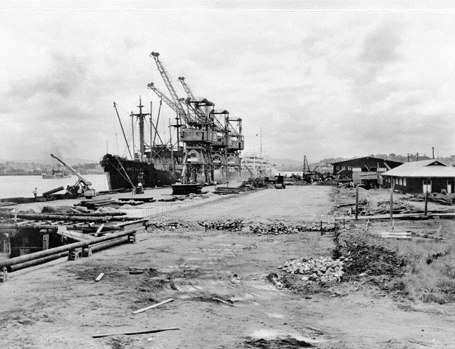
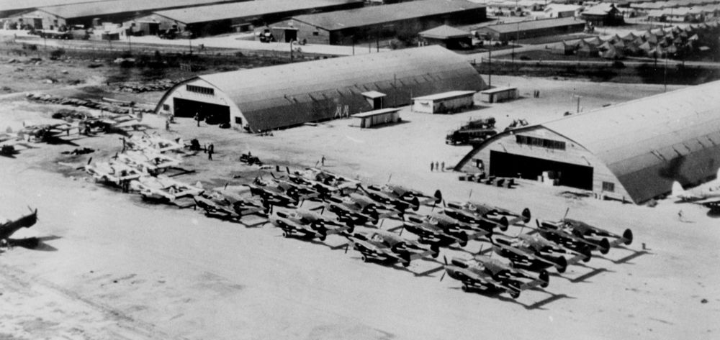
Image 31 Happy brides aboard ship at Hamilton, ready for their voyage to America. (Image State Library of Queensland)

Image 28 The USAT William H Holbrook arriving at Hamilton on 21 December 1941
(Image: State Library of Queensland)

Image 29 This military plan shows, outlined in red, the areas of Bretts Wharf taken over by the military in World War II. (Image National Archives of Australia)
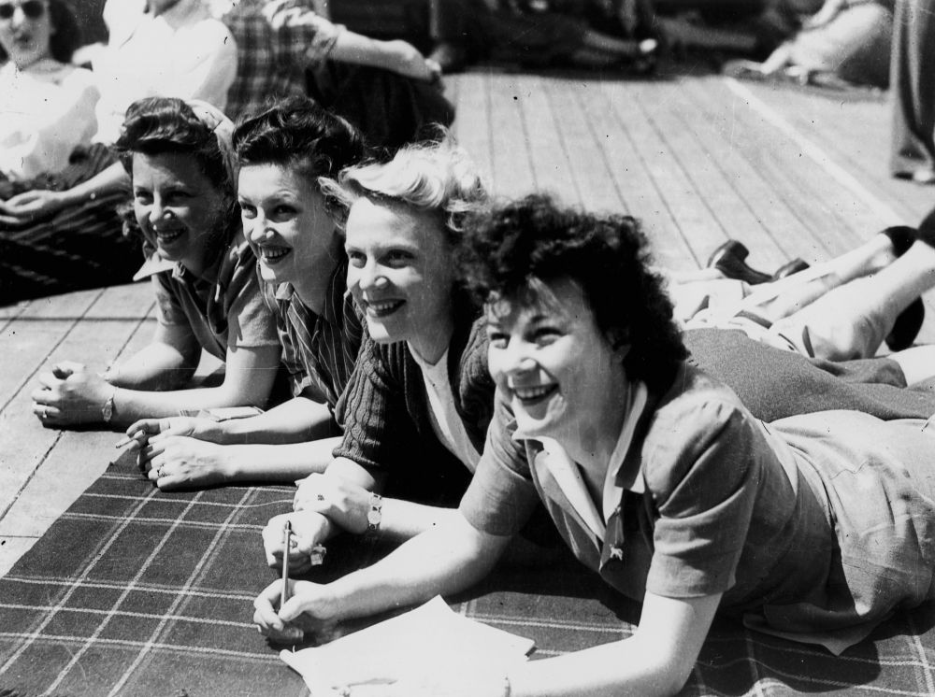
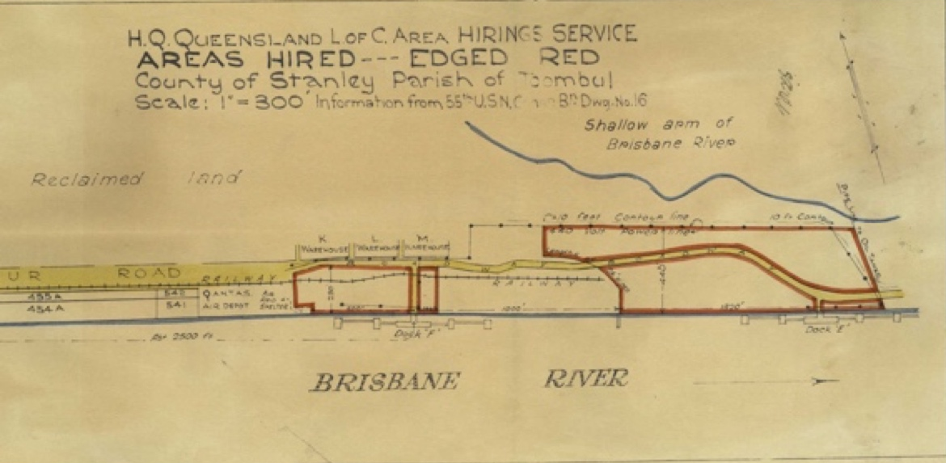

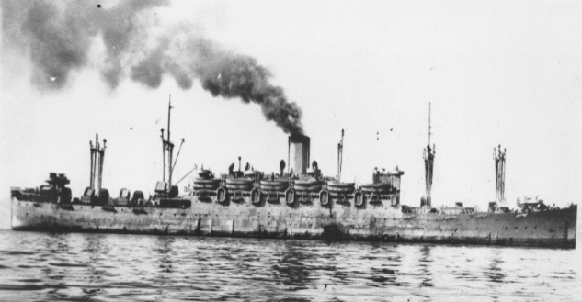
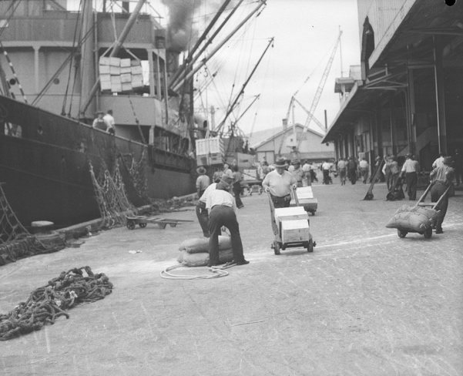
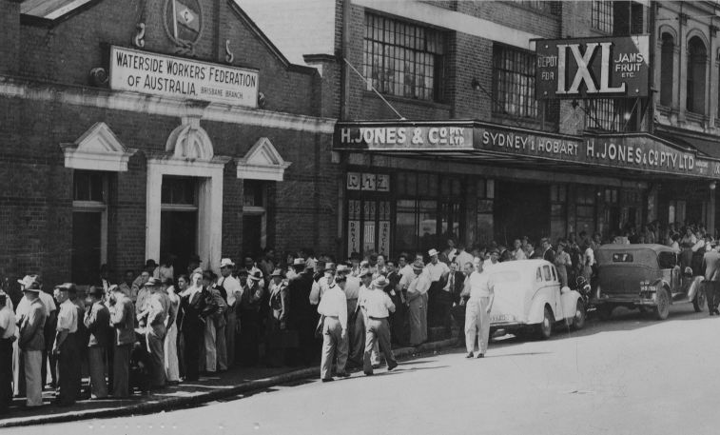

Image 32 at left. Waterside workers queuing for work at their ‘pick up’ point in Adelaide Street Brisbane. Image State Library of Queensland

Image 33 below. The labour-intensive work of ship unloading in the later 1940s in Brisbane Image State Library of Queensland

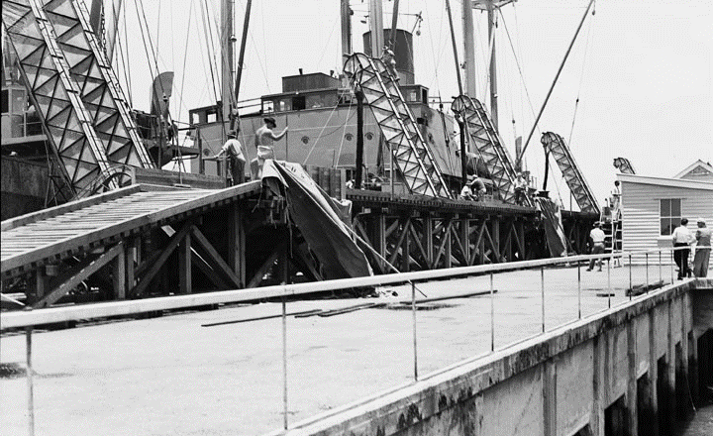
Image 35 Rather rough and ready: the BHP Wharf in 1953. (Image State Library of Queensland)
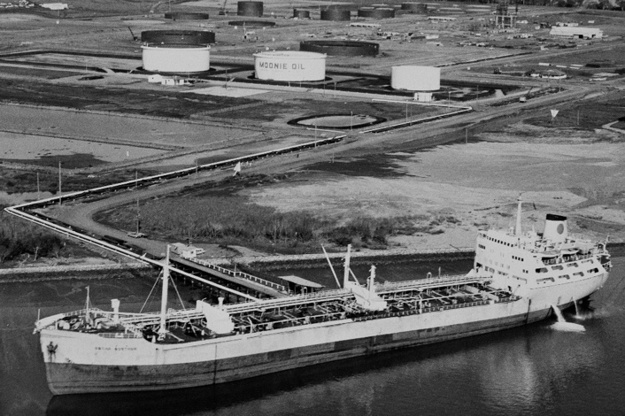

Image36 The SS Korimoko loaded the first bulk shipment of wheat to leave Brisbane. (Image Queensland State Archives)

.

Image 37 A tanker in Brisbane. The oil tanks and reclaimed land can be seen in the background. (Image National Archives of Australia)

1960-1980

SUMMARY
The Hamilton Wharves become the main container shipping and general cargo centre of the Port of Brisbane, an
Authority was established to develop a deepwater port at Fisherman Islands and to relocate port activities downstream. The 1974 flood, the worst since 1893, disrupted Brisbane’s progress, but not for long.

In the 1960s, planning and governance of the future of Brisbane’s port were underway. Oil companies like Amoco and Ampol constructed refineries and terminals near the river mouth, requiring extensive reclamation, to accommodate the large tankers. The outer river bar was widened, lengthened and deepened to 12.96 metres.

The Queensland Cabinet wanted to continue government ownership of wharves, but it recognised that constructing new wharves was very expensive, so they sought private tenders for passenger and heavy lift facilities. Brisbane Wharves and Wool Dumping Ltd also proposed to export sand products through the Hamilton wharves. Developments of this kind put considerable strain on existing infrastructure as the number of working wharves increased and larger ships required further deepening of the river channels.

By 1963, plans and surveys were underway for Harbour Road and MacArthur Road (now MacArthur Avenue), to service the future port area.
In 1964, the government planned a ferry terminal at Hamilton and discussed the need for a new cross-river bridge aligning Harvey Street and Links Avenue. Proposals to develop zoning plans for harbour industrial land were discussed.

In 1966, management for the port was passed from the Coordinator-General to the Department of Industrial Development while the Department of Harbours and Marine remained in charge of dredging operations Other agencies began to exert increasing influence including a federal government committee who reached the view that international trade was essential to Brisbane, but it would need container facilities to attract it.

By 1969, Brisbane’s first container terminal was built by private enterprise at Hamilton the first step in transforming the old Port of Brisbane from longitudinal wharves stretching, from the city to Pinkenba to a modern container port. In 1971, the Council Town Plan declared a large area adjacent to the port as Harbour Industrial Land.

In 1974, the Port of Brisbane Strategic Plan identified Fisherman Island as the site for a completely new container port. It also established the Port of Brisbane Corporation and identified inadequacies in port facilities at Hamilton. The 1974 flood disrupted Brisbane’s progress, but Northshore and the lower river escaped the worst of the onslaught. The city recovered and new infrastructure reflected the region’s growth and development including the new container port at Fisherman Island, enabling valuable riverfront land to be made available for redevelopment.

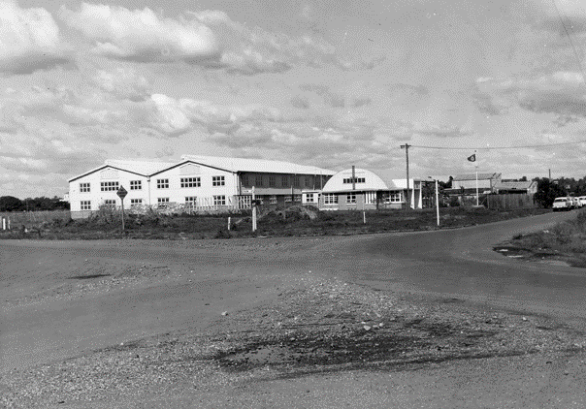
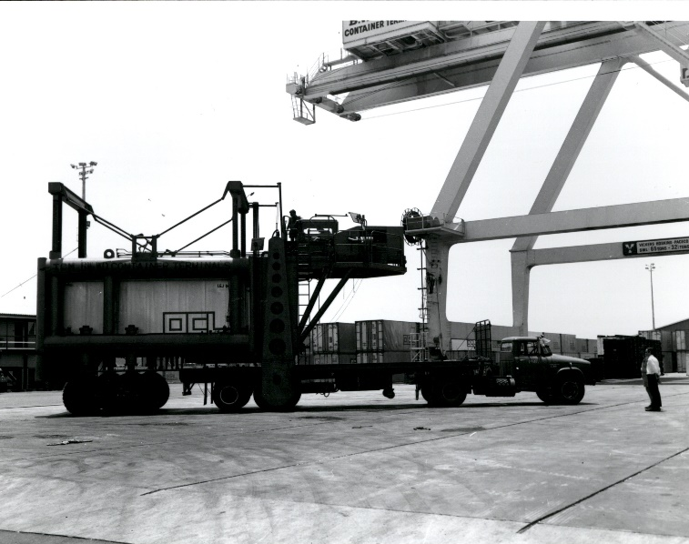

Image 41 Industrial buildings begin to appear on Fison Avenue. (Image Queensland State Archives)

Image 42 The first shipment of containerised mail at Hamilton 1969 (Image National Archives of Australia)

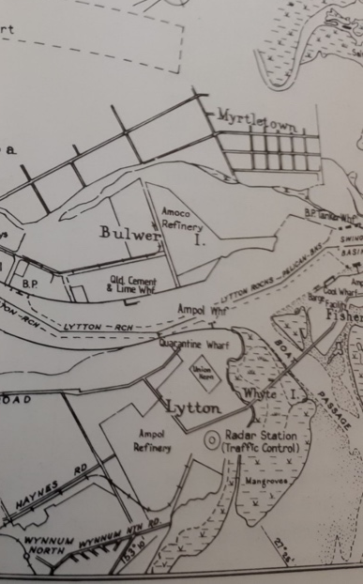
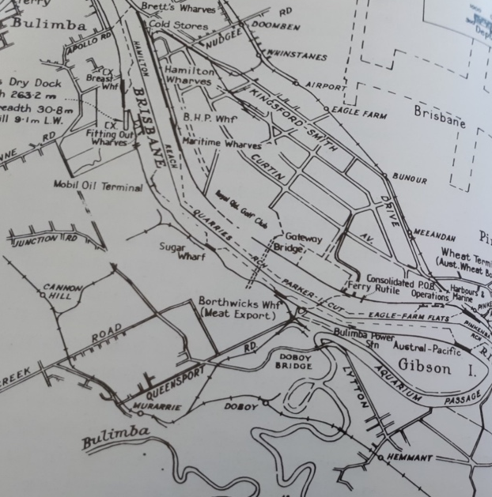

Image38 at left The complexity of the Hamilton section of the Port of Brisbane in 1964 with the Gateway Bridge (not completed until 1986) superimposed.
(Both Images W Davenport, Harbours and Marine, p.164) Image39 at right. Facilities developing at the mouth of the river.

1980-2000

SUMMARY
The Fisherman Islands Port Project was officially opened by the Queensland Premier, The Hon. Joh Bjelke-Petersen and infrastructure was developed and operations were gradually relocated. The Gateway Bridge and Portside Cruise Terminal opened, Expo 88 and Commonwealth Games put Brisbane on the map and urban renewal of old wharf areas commenced.

The opening of the new container port, Port of Brisbane, at Fisherman Islands and relocating port operations by 2019, required intense planning. Port facilities at Hamilton were also increasingly constrained by urban encroachment. The emerging idea of ‘Australia Trade Coast,’ the area from Hamilton to Luggage Point on the north side of the river and between Colmslie to Fisherman Islands on the south side, was born.

The opening of the first container terminal in 1980 was followed by the opening of the second, within a few years. With the government preferring competition between two terminals. On 7 August 1981, Columbus Queensland was the first ship to use the new No1 container terminal at Fisherman Island. By 1983, there were two operational container terminals, a bulk coal exporting facility and a bulk cement importing facility, plus construction of a bulk grain terminal was underway.

Containerisation was a major driver of urban renewal in cities around the world, and many industrial areas in Brisbane, like Northshore and the woolstores at Teneriffe, became available for redevelopment when their wharves were replaced by the new container port at the mouth of the river. To enable this, in 1985, the government called for expressions of interest for a staged redevelopment of Hamilton Reach. Leighton Holdings submitted a preliminary proposal to redevelop a 95–hectare area including the Cold Stores and Brett’s Wharf, with an estimated cost of $50 million. Most of this land was either vacant Crown land, or land vested in the Port of Brisbane. But the Brett’s company made it known that it would require its facilities for a further 10–15 years. As a number of companies registered their interest, Cabinet concluded that it was ‘clear that there is considerable and widespread interest in the redevelopment of the Hamilton Reach’.

On 11 January 1986, the $92 million Gateway Bridge (later re-named to Sir Leo Hielscher Bridge) opened. It was designed to assist north-south traffic to avoid the central city area. The bridges’ distinctive shape is a function of the air traffic requirement, under 80 metres above sea level, coupled with shipping needs requiring a navigational clearance of 55 m. The bridge held the world record for a pre-stressed concrete free cantilever bridge for more than 15 year and the box girder is still the largest pre-stressed concrete, single box in the world, measuring 15 m deep at the pier, with a box width of 12 m and overall deck width of 6 lanes–22 m.

In the early 1990s, the 1926 Mactaggarts Woolstore at Tenneriffe, became the catalyst for the conversion of the largest collection of riverside woolstores in Australia into apartments. Inner city living and urban renewal was gaining popularity and the Brisbane River became a focus for public appreciation, redevelopment schemes and urban planning priority. Cycle paths and riverside promenades, enthusiastically received during Expo 88, became more popular. Success in urban renewal relied on a progressive council with a flexible planning approach, community involvement, catalyst projects and developer innovation. In 1991, the Urban Renewal Taskforce was created establishing bold visions for the revitalisation of derelict industrial areas in Fortitude Valley, Newstead, Teneriffe, New Farm, Bowen Hills and the Brisbane riverfront.

In 1996, the first City Cat service began operation with six ferries running from the University of Queensland to Bulimba. The service was extended to Brett’s Wharf and Apollo Terminal (Bulimba). Although cross-river ferries had operated on the Brisbane River since the 1840s, this was the first ferry service to run up and down the river.

The development of a terminal for cruise liners had a difficult history in Brisbane. The opening of Portside Cruise Terminal, built on the old Cold Stores Wharf, in 2006 was a major development in Queensland tourism and a significant step in the renewal of the former wharves and industrial area. However, the height restrictions for passing under the Sir Leo Hielscher bridge prevented larger liners from docking at Portside and instead they had to dock at the Port of Brisbane at Fishermen Island.

2000-2020
SUMMARY
Construction of second gateway bridge, a new city cat terminal, urban renewal and evolution of Northshore, establishment of development authorities to transition Northshore (the Northshore Development Group, ULDA, and Economic Development Queensland), placemaking projects and delivery of new infrastructure to support a new community

Strategic planning was once again at the forefront of transforming and renewing the port area. Tenure constraints needed consideration in the planning process—with a mix of government-owned and privately-owned land, varying tenures, continuing leases and ongoing port operations destined to be phased out by 2020. A staged and strategic approach to property management, infrastructure delivery and redevelopment would be necessary.

During the 2000s, urban renewal of Northshore began at the western end, the old Brett’s Wharf site, new high-rise apartments, villas and restaurant, serviced by the Brett’s Wharf City Cat terminal. On the old Cold Stores Wharf site the new Portside Wharf,$750 million Brisbane Cruise Terminal, associated high-rise apartments, supermarket, retail outlets, restaurants, cinema and public plaza.

In 2003, the Port of Brisbane Corporation formed the Northshore Development Group to manage master planning for the port and industrial area and necessary infrastructure delivery. The master plan addressed the requirements of Brisbane City Council’s planning scheme (City Plan 2000) with the concept of developing an urban village, with a supermarket, medical centre, commercial offices, restaurants, apartments, parks and continuous public access along the river.

Port land in the western area was sold to developers to construct facilities in accordance with the master plan and land sale returns would fund Port of Brisbane Corporations relocation commitments, with surplus returned to the Queensland Government. Developers submitted their plans to Brisbane City Council for development approvals at this time. The next precinct for redevelopment was the eastern area of Northshore, next to the Royal Queensland Golf Club. This would include residential development, a riverside park and restaurant, and a new City Cat Terminal, Northshore Hamilton.

The Northshore Development Group’s master plan envisioned ‘a vibrant and high quality mixed-used urban community based on design excellence, environmental leadership and commercial viability’.

In 2006, in response to increased demand for housing to accommodate the rapid growth in population, Council’s draft planning scheme (CityShape 2026) identified Northshore as regionally important, in accommodating a signiﬁcant proportion of Brisbane’s population growth.

In 2007, the Queensland government passed the Urban Development Authority Act 2007 which created a statutory authority, the Urban Land Development Authority (ULDA), to tackle issues of population growth and declining housing affordability, with powers to streamline and accelerate planning and delivery of urban development and associated infrastructure. The ULDA were tasked with catalysing urban renewal projects and ensuring ‘vibrant inclusive communities’ were created close to the centre of cities. On 27 March 2008, the 304-hectare Northshore Hamilton Urban Development Area (UDA), was declared.

In July 2008 the Northshore Riverside Café opened located in the 2.5 ha parkland on the banks of the Northshore development. Delivered by the Northshore Development Group, these assets were subsequently handed over to Brisbane City Council to manage in November 2011.

The Northshore Hamilton UDA was to be transformed into a vibrant mixed-use community that reflected the principles of the earlier master plan and community input. Following the state election in 2009, the government ordered reconsideration of public submissions on the draft planning scheme which included public access to the river, need for public transport, more open and recreation space including cycle and pedestrian paths and environmental protection. There were also concerns over high density development, infrastructure contributions, carparking ratios, building setbacks and heights and interfaces with and balance of mixed-use development and established industrial uses. On 3 July 2009, the development scheme prepared by the ULDA, was adopted.

On the 9 April 2010 the Queensland Government formally gazetted the transfer of 64 hectares of Port of Brisbane owned land at Northshore to the ULDA. Existing tenancies that were considered to be ongoing port trade related continued to be managed by the Port of Brisbane under concurrent lease arrangements until December 2018.

As the new development assessment authority, the ULDA approved several development applications including: a $500 million Devine/Leighton Hamilton Harbour proposal with 432 apartments, 31,000 m2 of retail and commercial space and 1000 m2 park; a Multiplex proposal for another development at Portside with 250 apartments; and an Australand (now Frasers Property) proposal for a residential development on the riverfront adjoining the Royal Queensland Golf Club. Brisbane Technolgy Park (BTP) commenced development in 2013 and continues to grow.

In 2010, the duplicate $350 million Gateway Bridge was opened along with major upgrades to surrounding motorways. The Queensland Government renamed the bridges in honour of Sir Leo Hielscher, a long serving public servant who headed the Treasury Department and drove Queensland’s industrial development. The Royal Queensland Golf Club lost seven holes due to land resumption required for the project and the course was re-designed by Michael Clayton, a golf course designer, who had won the Australian Amateur Championship when it was held at the club in 1978. A new lease ensured that there was no possibility of extension to Curtin Avenue.

In January 2011, severe flooding, the worst since 1974, affected Brisbane and as in previous floods, only a little water crept over the beach within the Northshore Riverside Park, but debris including boats, pontoons, a walkway and a restaurant found its way to the lower reaches of the Brisbane River.

In October 2011, the State Government funded $4.58 million new City Cat terminal at Northshore Hamilton was opened and commenced operations.

In February 2013, the Urban Land Development Act 2007 was repealed and replaced with the Economic Development Act 2012 and all UDAs under the previous legislation became Priority Development Areas (PDAS). Economic Development Queensland (EDQ), took over responsibility for all PDAs including Northshore.
EDQ manages, the 64 hectares of government owned land at Northshore and has planned and delivered public infrastructure projects to support the areas transition from an industrial port to a vibrant residential community including land decontamination, demolition of unusable old wharves, repurposing wharf timber, development of new parks, streets, pedestrian and cycle infrastructure, opened the riverfront up to the public, and establishment of successful and much loved placemaking interventions such as Eat Street Northshore, and the Northshore Tennis Park.. . Old wharf timbers have been repurposed into tables and chairs at Eat Street, showcased in the construction of The Deck an information hub for visitors and residents (winning a 2018 National Architecture Award, Small Project Architecture), used as furniture in parks and incorporated into new developments at Northshore creating mementos and celebrating the area’s maritime history.

In 2013 the $1.75 million new river walk extension was opened by then Deputy Premier Jeff Seeney. This included riverside walkways, improvements and public artwork along the Hamilton Reach riverside residential precinct at Northshore.

In 2013 Eat Street Markets Brisbane’s first pop-up container village with over 50 recycled shipping containers reconfigured as mini-restaurants, bars, galleries and produce stores, opened. Massively popular and drawing over 1 million visitors a year and drawing crowds from outside Brisbane, the destination markets outgrew its riverfront location (Hamilton No 3 wharf) and in April 2017, relocated to a larger riverfront location 800 metres east along MacArthur Avenue (Maritime No 2 wharf). At the new location Eat Street is now known as Eat Street Northshore and has 180 recycled shipping containers, 1334 on-site car parks, a pop-up park (The Lawn) providing green space, a riverwalk connecting to the Northshore Hamilton City Cat terminal and the award winning, architecturally designed pavilion, The Deck

The creation of the Eat Street Northshore has played a major placemaking role, engaging the public, providing public access to the riverfront and putting Northshore on the map. Eat Street grew out of an idea for a seafood festival proposed by market guru, Peter Hackworth. However, the river breezes did not suit open air stalls, and so, the idea of using shipping containers was born. EDQ ran a 3–week festival, Containeraval, and partnered with the Queensland University of Technology in the design of containers for the festival, which proved immensely successful. Eat Street Markets opened in the last week of Containerval in November 2013. John Stainton, a well-known television producer. John Harrison, a successful Brisbane businessman, and Jacki MacDonald, a former popular television personality, joined Peter Hackworth to develop Eat Street Markets. For John Stainton, developing Eat Street was like creating a very big television set. The markets also served as an important incubator for start-up food and beverage operators and many chefs have gone on to develop their own restaurants.

Eat Street was immensely popular from the time of its opening, offering a great variety of cuisines and entertainment, in a vibrant atmosphere each Friday and Saturday night. On the first evening, vehicles filled all 450 carparks and spilled into the road outside. Chefs worked frantically to keep up with the demands of long queues of patrons. In 2019, Eat Street is open on Friday and Saturday nights and Sunday afternoon and evening. It is an outstanding example of public and private partnership delivering commercial and community benefits.

Northshore has also hosted large events including the internationally acclaimed Cirque du Soleil in 2012, 2015 and with plans for a 2020 show. In 2018, the Northshore Tennis Park was developed to increase the variety of publicly accessible activities along the waterfront.

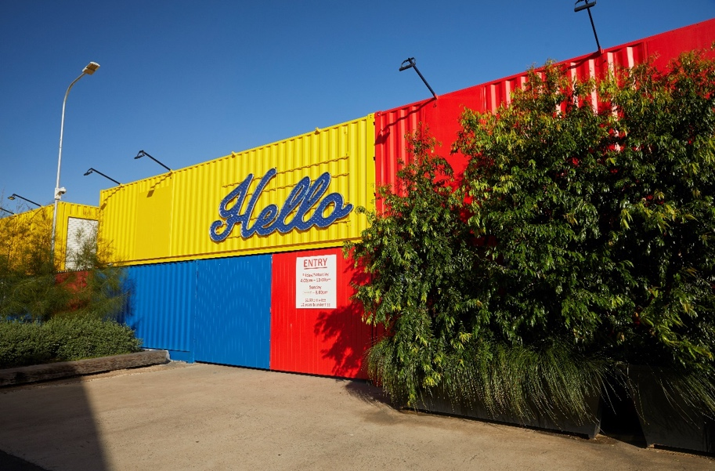
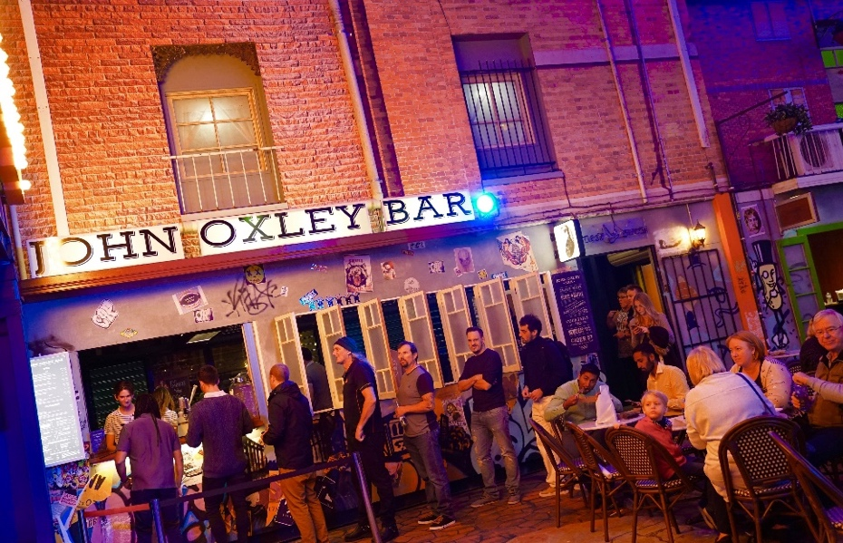

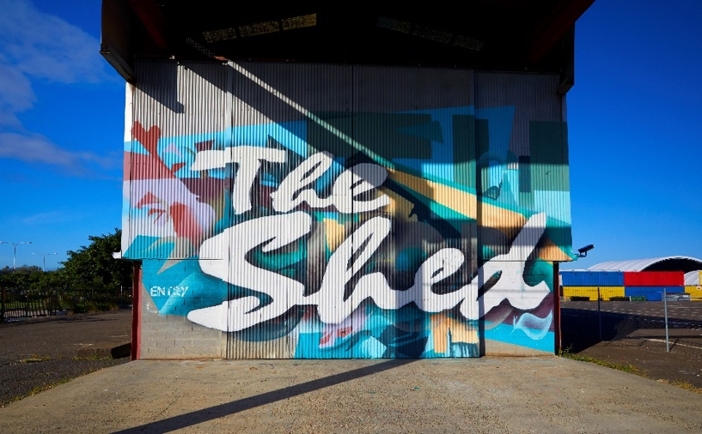
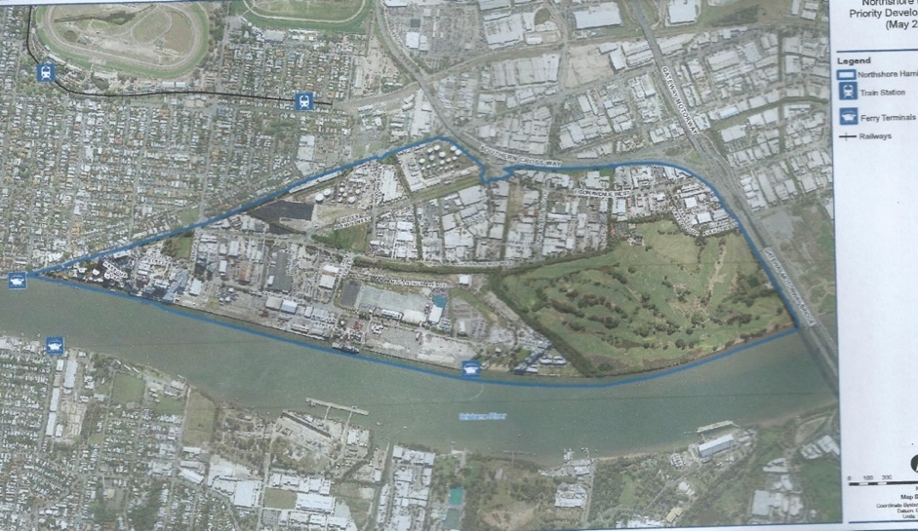
HIGH RES IMAGE OF THE Northshore PLAN NEEDED HERE Image 46. NorthshoreHamilton Priority Development Area
(PDA) outlined in blue (Image Economic Development Queensland)

Image 47 The colourful re-cycled shipping containers at Eat Street. Image: Economic Development Queensland

Beyond 2020

In keeping with its past, Northshore continues to transform itself from an Aboriginal campsite and natural swampland, a reclaimed industrial port, to a vibrant and evolving community. It continues to ebb and flow, like its river, with its cycle of change and modification.

The river has long been a focus for Northshore, for Aboriginal people of the Turrbal language group who resided near the river bank, who lived from and celebrated the river ecosystem and who used the natural low-lying river crossings as pathways. For the early Europeans, who took joy in water based recreational activities at Northshore and the lower river reaches and who used the river as a means of transport.

The river became the life-force of the growing settlement, it’s economic trade route and this transformed the river as engineers sought to ‘improve’ it, to tame it, deepen, widen and modify it to enable a growing shipping trade that supported export of local industries and the import of much needed resources. In doing so, the river disappeared behind an ever-stretching wall of wharves and industrial sheds.

As Brisbane transformed, the river re-emerged and has been rediscovered and embraced by its people. The people of twenty-first century Brisbane are living closer to their river and its city centre. They want to see, access, experience and enjoy it. So, it is fundamental that the riverfront is returned to its people at Northshore, so that everyone can experience as Northshore as it continues to transition into the uses the city requires. Northshore’s history is to be acknowledged and celebrated as it transforms, like the repurposing of wharf timber to street furniture and public buildings, the reuse and repurposing of historic iconic nautical and shipping materials and infrastructure in public places, the use of shipping containers, sheds and wharves for interim uses as well as embracing uses that are sympathetic to it’s transformation like Eat Street Northshore.

EDQ will continue to plan, manage and deliver the infrastructure and placemaking projects necessary to support the transformation, and build the necessary partnerships between public and private enterprise to ensure a high quality, sustainable, innovative, people focussed community for all to enjoy.

ENDNOTES

R Kerkhove, Aboriginal campsites of greater Brisbane. An historical guide, Brisbane, Boolarong, 2015, pp. 54, 68.
R Kerkhove, Aboriginal campsites of greater Brisbane, p. 80.
R Kerkhove, Aboriginal campsites of greater Brisbane, p. 82. See also Brisbane Courier, 27 Sept 1930, p. 21, 30 March 1929, p. 18.
Reproduced from R Kerkhove, Aboriginal campsites of greater Brisbane, p. 80.
Oxley did not ‘discover’ the Brisbane River. Three convict timber-getters, Pamphlet, Finnegan and Parsons, had been blown north in a storm and found the entrance to the River and, in 1823, showed it to their rescuer, John Oxley. Low islands obscured the entrance to the River and it was not noticed by earlier navigators exploring Moreton Bay.
Oxley’s report to the Governor, J G Steele, The explorers of the Moreton Bay district, p. 110.
Oxley, Report, cited in J G Steele, Explorers, p. 123.
W R Johnston, Brisbane. The first 30 years, Brisbane, Boolarong, 1988, p. 40.
W R Johnston, Brisbane. The first 30 years, p. 41
‘Hoop pine’, www.business.qld.gov.au/industries/farms-fishing-forestry/forests-wood/properties-timbers/hoop-pine, ‘Hoop pine’, http://era.daf.qld.gov.au/id/eprint accessed 10 Jan 2019.
Lockyer, Journal, 13 Sept, 4-9 Oct 1825, pp. 189, 202.
Fraser to Colonial Secretary Macleay, July 1829, cited in J G Steele, Brisbane Town in convict days, p. 113.
Fraser to Colonial Secretary Macleay, July 1829, cited in J G Steele, Brisbane Town in convict days, p. 113.
C C Petrie, Tom Petrie’s reminiscences of early Brisbane, p. 224.
W Davenport, Harbours & marine : port & harbour development in Queensland 1824-1985, Brisbane, Department of Harbours and Marine, 1986, p. 368.
W R Johnston, Brisbane. The first 30 years, p. 73.
W R Johnston, Brisbane. The first 30 years, p. 75.
G Greenwood & J Laverty, Brisbane 1859-1959, Brisbane, Otto Ziegler, 1959, p. 78.
W R Johnston, Brisbane. The first 30 years, p. 92.
W R Johnston, Brisbane. The first 30 years, p. 101.
W R Johnston, Brisbane. The first 30 years, pp. 153, 155.
W R Johnston, Brisbane. The first 30 years, p. 197.
G Greenwood & J Laverty, Brisbane 1859-1959, Brisbane, Otto Ziegler, 1959, p. 205.
Brisbane Courier, 16 Aug 1864, p. 4.
G Greenwood & J Laverty, Brisbane 1859-1959, Brisbane, Otto Ziegler, 1959, p. 206.
Brisbane Courier, 9 Oct 1865, p. 6.
Brisbane Courier, 30 May 1867, p. 2, Telegraph, 3 Jan 1881, p. 2..
Bright and Co were the agents for the Cabot. Brisbane Courier, 24 Sept 1869, p. 2.
See, eg, Brisbane Courier, 14 July 1870 p.3, 3 July 1877 p.3.
Brisbane Courier, 14 Aug 1865, p. 2
W Davenport, Harbours and Marine, pp. 205, 207.
W Davenport, Harbours and Marine, p. 205.
The Week, 30 May 1885, p.10. Brisbane Courier,12 May 1888, p. 7.
Telegraph, 4 Oct 1886, p. 2. Moreton Mail, 8 Nov 1889, p. 2.
See eg, Brisbane Courier, 27 Feb 1886, p.3, 8 Jan 1892, p.2.
W Davenport, Harbours and Marine, p. 279.
Report of Commission on Additional Wharfage for the Port of Brisbane 1875, W Davenport, Harbours and Marine, p. 217.
W Davenport, Harbours and Marine, p. 208.
EA Cullen to Chief Engineer for Harbours and Rivers, 20 June 1890, Correspondence, E A Cullen regarding a survey of the Brisbane River, Series 6389 Item 980035, QSA
Brisbane Courier, 5 April 1898, page 6
Brisbane Courier, 5 April 1898, page 6
W Davenport, Harbours and Marine, pp. 374-5.
Telegraph, 20 Oct 1882, p. 3.
Telegraph, 3 Jan 1881, p. 2
Myles Sinnamon E 2012 The business of Toursim:Queenlands’s 1880’s theme park, John Oxley website, edited by Helen Gregory as resident Historian
W Davenport, Harbours and Marine, pp. 367-8.
Collector of Customs, Commonwealth of Australia to Cullen, 22 Nov 1922, Brisbane River – Wharves – correspondence re improvements to Brisbane River wharves, a proposed wharfage scheme and training walls, Series 6389 Item 979705 QSA.
E A Cullen, The improvement of the Brisbane River, London, Institute of Engineers, 1922, pp.5-6.
Engineer for Harbours and Rivers to Private Secretary Government House 11 March 1914 encl. information regarding the port of Brisbane for Governor, Brisbane River – Wharves – correspondence re improvements to Brisbane River wharves, a proposed wharfage scheme and training walls, Series 6389 Item 979705 QSA
Engineer for Harbours and Rivers to Private Secretary Government House 11 March 1914 encl. information regarding the port of Brisbane for Governor, Brisbane River – Wharves – correspondence re improvements to Brisbane River wharves, a proposed wharfage scheme and training walls, Series 6389 Item 979705 QSA
Brisbane Chamber of Commerce to Portmaster, 30 April 1912, Brisbane River – Wharves – correspondence re improvements to Brisbane River wharves, a proposed wharfage scheme and training walls, Series 6389 Item 979705 QSA.
H Gregory, The Brisbane River story. Meanders through time, Brisbane, 1996, p.133.
Brisbane Courier, 14 March 1919, p. 6.
Brisbane Courier, 15 March 1919, p.4.
W Davenport, Harbours and Marine, p. 378.
"Royal Queensland Golf Club". Australian Golfer. Retrieved 29 May 2016. - ^ "Royal Queensland Golf Club". Retrieved 21 October 2014.
H H Marshall, Royal Queensland. The first 70 years, Bris, RQGC, circa 1993, pp.11-18.
H H Marshall, Royal Queensland. The first 70 years, pp. 85-6.
H H Marshall, Royal Queensland. The first 70 years, Bris, RQGC, circa 1993, pp.11-18.
"Moreton Bay". Queensland Places. Centre for the Government of Queensland. Retrieved 27 September 2014.
Collector of Customs, Commonwealth of Australia to Cullen, 22 Nov 1922, Brisbane River – Wharves – correspondence re improvements to Brisbane River wharves, a proposed wharfage scheme and training walls, Series 6389 Item 979705 QSA.
Technical drawings, Hamilton Cold Stores Wharf, Diagram of Piles (Wharf Completed Dec. 1922), Series 6216, Item 929782, QSA.
G Lewis, A history of the ports of Queensland, p. 211.
G Lewis, A history of the ports of Queensland, p. 211.
For more information on the development of Brett’s see Brisbane Courier, 1 Aug 1933, p. 16.
Telegraph, 2 Feb 1929, p. 2.
E B Cullen, The construction of Brett’s wharf, London, Institution of Engineers, 1933.
W Davenport, Harbours and Marine, p. 522.
G Lewis, A history of the ports of Queensland, p. 212.
Relief work included repairs to the Hamilton training wall in 1931. W Davenport, Harbours and Marine p. 531.
Courier-Mail, 8 Aug 1935, p. 21.
Courier-Mail, 4 July 1935, p. 13, 15 Feb 1936, p. 6.
"Magnificent Machines – Home-grown Legends". The Sydney Morning Herald. 16 December 2003.
Queensland Heritage Council, Entry in the Heritage Register, Archerfield Second World War igloo complex, No 602150
G Lewis, A history of the ports of Queensland, p. 211.
E A Cullen, draft of article, ‘The port of Brisbane’, Brisbane River – Wharves – correspondence re improvements to Brisbane River wharves, a proposed wharfage scheme and training walls, Item 979705, Series 6389, QSA/
Courier-Mail, 15 Aug 1939, p. 3.
Eagle Farm airfield, www.ww2places.qld.gov.au accessed 13 Jan 2019.
RAAF Eagle Farm - air raid shelter, slit trenches and machine gun emplacements, Item KS 56/7, Series BP 243/1, National Archives of Australia. Memo to Director of Works Brisbane, 1 March 1942, Item KS 56/7, Series BP 243/1, National Archives of Australia.
W Davenport, Harbours and marine, p. 534.
Telegraph, 8 Jan 1946, p. 3.
Courier-Mail, 21 Feb 1946, p. 3.
See eg, Telegraph, 15 Dec 1948, p. 3.
Pinkenba US warehouses – building and administration, Series J56, QL544 Part 2, NAA; W Davenport, Harbours and Marine, p.534
W Davenport, Harbours and Marine p. 534.
W Davenport, Harbours and Marine, p.526.
See for instance, Brisbane Telegraph 30 June 1948 p 5, 29 December 1952, p 3, Maryborough Chronicle, 17 April 1951 p 1, Courier-Mail 29 March 1954, p 1.
Waterside Workers re Rotation of hatches strike, Brisbane, Item BL 19573 NAA.
Waterside Workers re Rotation of hatches strike, Brisbane, Item BL 19573 NAA.
Brisbane River Wharves Correspondence, Series 6389 Item 979746, QSA.
G Lewis, A history of the ports of Queensland, p. 248.
W Davenport, Harbours and Marine, pp. 535, 538, Queensland Parliament, Votes and Proceedings, 9 Aug, 7 Sept 1955.
Brisbane River – Reclamation – Daily reports re reclamation work at Hamilton and Parker Island, Series 6389 Item 979746 QSA covers the period between January 1940 and July 1954. See also Coordinator General’s Dept – Cooperation with Lands Dept – Hamilton Lands – Wharf and dock requirements Series 3160 Item 2286550, QSA
G Lewis, A history of the ports of Queensland, p.249.
W Davenport, Harbours and Marine, pp.617, 712.
Minutes of Cabinet, 21 Dec 1956 and submission 7462 ‘Future policy for wharf ownership in the Port of Brisbane’ QSA.
Coordinator General to Brisbane City Council 17 Jan 1964, Coordinator General’s Department – Cooperation with Lands Dept – Hamilton Lands – Wharf and dock requirements, Series 3160 Item 2286550 QSA,
W Davenport, Harbours and Marine, pp.702, 713.
Coordinator General to Under Secretary, Public Works, 26 Sept 1963, Brisbane City Council to chief engineer Harbours and Marine, 28 April 1955Coordinator General to Under Secretary, Public Works, 26 Sept 1963, Brisbane City Council to chief engineer Harbours and Marine, 28 April 1955, Coordinator General’s Department – Cooperation with Lands Dept – Hamilton Lands – Wharf and dock requirements, Series 3160 Item 2286550 QSA.
G Lewis, A history of the ports of Queensland, p.252.
G Lewis, The ports of Queensland, p.251.
G Lewis, A history of the ports of Queensland, p.252.
Chapter 2, planning document supplied by Department of State Development.
Chapter 2, planning document supplied by Department of State Development, p.2.
Chapter 2, Hamilton Port relocation strategy, p.1.
Minutes of Cabinet, 10 Feb 1981, Decision 34439, Submission, 30743, QSA.
W Davenport, Harbours and Marine, p.720.
W Davenport, Harbours and Marine, p.720.
Submission 43308 with Minutes of Cabinet, 9 Dec 1985, QSA.
Minutes of Cabinet 9 Dec 1985, Decision 47719, Submission 43308, QSA.
Warren Pitt (26 September 2007), Gateway Upgrade Project well underway, Queensland Government, retrieved 12 January 2016
Brett Gillan, ‘Twenty years of urban renewal in Brisbane’, Courier-Mail, 21 July 2014.
Brisbane City Council, ‘Urban renewal Brisbane 25 years. Creating a new world city’..
Continuing operations included loading ships with sand brought from Stradbroke Island by ferry and truck. This operation was scheduled to conclude when sand mining on the island ceased in 2019. Hamilton port relocation strategy Chapter 2, p. 1, document supplied by the Department of State Development.
Hamilton port relocation strategy Chapter 2, document supplied by the Department of State Development.
Hamilton port relocation strategy Chapter 22, document supplied by the Department of State Development.
Hamilton port relocation strategy Chapter 7, document supplied by the Department of State Development.
Final report of the Urban Land Development Authority 1 July 2011-31 January 2013 http://www.dlgrma.qld.gov.au accessed 11 Jan 2019.
www.dsdmip.qld.gov.au/edq/Northshore-hamilton-brisbane accessed on 3 Feb 2019.
Urban Land Development Authority, Northshore Hamilton Community Newsletter No 1, April 2008.
Urban Land Development Authority, Northshore Hamilton Community Newsletter No 3, June 2009.
Urban Land Development Authority, Northshore Hamilton Community Newsletter No 3, June 2009.
Warren Pitt (26 September 2007), Gateway Upgrade Project well underway, Queensland Government, retrieved 12 January 2016
H H Marshall, Royal Queensland. The first 70 years, Bris, RQGC, circa 1993, p.103.
H H Marshall, Royal Queensland. The first 70 years, Bris, RQGC, circa 1993, p.103.
Information on Eat Street provided by John Stainton.
Information on Eat Street provided by John Stainton.

